

VistA Blood Establishment Computer Software (VBECS) – Vision Interface Configuration and Setup Guide, Version 4.0

September 2018

Department of Veterans Affairs

Enterprise Project Management Office

# Revision History

| **Date** | **Revision** | **Description** | **Author** |
| --- | --- | --- | --- |
| 01-25-17 | 1.0 | Initial version. (Defect 424731) | BBM team |
| 05-05-17 | 2.0 | (Defect 497919)  Updated Fig. 6, Fig. 7, Fig. 10, Fig. 22 and Fig. 30 to reflect changed configuration file names and additional rules.  Updated Appendices A and B with modified test codes for phenotyping. Updated Appendices C and D with modified rules.  Updated section Instrument Manager version with information that the interface requires Specimen Management Module activated in IM.  Added Chapters 4 and 5 to the Set Up Automated Instrument section. | BBM team |
| 06-30-17 | 3.0 | (Defect 546927)  Fixed typo in phenotyping codes in Appendix A and Appendix B. | BBM team |
| 09-20-18 | 4.0 | (Task 797333)  Updated Appendices A – D with new test code mapping and rules. Added VBECS Rh Phenotype template to Appendix E. Removed section 5 “Limitation of the crossmatch testing”. Updated driver information. Updated Figures 5, 6, 7, 8, 10, 22, 30. Updated name of both configuration files.  Appendix F: CA SDM Support Ticket Template was removed which resulted in Appendix G being renamed to Appendix F: Validation Planning and Example Test Scenarios. | BBM team |

Table of Contents

Revision History 2

Table of Contents 3

Introduction 4

Related Manuals and Reference Materials 5

Set Up Automated Instrument 6

1 Network Connectivity Setup 6

2 Testing Profiles Setup 6

3 User ID Setup 6

4 Manual Versus Automated Review 6

Set Up Instrument Manager 8

1 Instrument Manager Version 8

2 Instrument Manager to Automated Instrument Connectivity 8

3 Installing Instrument Driver 9

4 Set Up Instrument Side Configuration 9

4.1 Download Instrument Configuration Files 10

4.2 Import Instrument Side Configuration 11

4.3 Verify Test Code Mapping for Instrument Side Configuration 14

4.4 Verify Rules for Instrument Side Configuration 15

4.5 Configure Rules for Instrument Side Configuration 16

4.6 Import VBECS (HL7) Side Configuration 19

4.7 Verify Test Code Mapping for VBECS Side Configuration 22

4.8 Verify Rules for VBECS (HL7) Side Configuration 23

5 Set Up HL7 Connection to VBECS TEST 26

6 Set Up Instrument Connection 28

7 Test New Connections 30

8 Validate Instrument Connectivity to VBECS TEST 30

9 Set Up HL7 Connection to VBECS PROD 31

Glossary 35

Appendices 36

Appendix A: Instrument Side Mapping 36

Appendix B: HL7 (VBECS) Side Mapping 42

Appendix C: Instrument Side Rules 46

Appendix D: VBECS (HL7) Side Rules 51

Appendix E: Vision Testing Profiles 52

Appendix F: Validation Planning and Example Test Scenarios 53

Test Group One: AI interface disabled 54

Test Group Two: Verify AI individual test(s) 55

Test Group 2 Scenario 1: Verify AI TAS test 56

Test Group 2 Scenario 2: Verify AI serologic crossmatch test 57

Test Group 2 Scenario 3: Verify AI patient diagnostic tests 58

Test Group 2 Scenario 4: Verify AI blood unit tests 59

Introduction

VBECS is a Blood Bank application that facilitates ongoing compliance with Food and Drug Administration (FDA) standards for medical devices and enhances the VA’s ability to produce high-quality blood products and services to veterans. The system follows blood bank standards, standards of national accrediting agencies, FDA regulations and VA policies.

VBECS 2.2.0 introduced a new interface for blood bank testing performed by blood bank instrumentation to VBECS. The implementation of the interface and its associated validation are described in this guide.

Unauthorized access or misuse of this system and/or its data is a federal crime. Use of all data must be in accordance with VA security and privacy policies.



The U.S. FDA classifies this software as a medical device. Unauthorized modifications will render this device an adulterated medical device under Section 501 of the Medical Device Amendments to the Federal Food, Drug, and Cosmetic Act. Acquiring and implementing this software through the Freedom of Information Act requires the implementer to assume total responsibility for the software and become a registered manufacturer of a medical device, subject to FDA regulations. Adding to or updating VBECS software without permission is prohibited.



Instructions in this Setup Guide must be followed for the interface to deliver information to VBECS. Local validation is required to confirm proper operation before use. Validation and verification is required to ensure connectivity to VBECS.



This guide is provided to assist you with the multi-faceted required setup of your local blood bank testing instrument(s), Data Innovations Instrument Manager (DI IM) and VBECS to electronically transmit instrument test results to VBECS for use in the transfusion service.

There are specific setup requirements to test and transmit those testing results to VBECS for review using DI IM (Figure 1).

Figure : Hardware and Interface Configuration



Testing instrument

VBECS

DI IM

Your local testing instrument(s) communicates with DI IM via an instrument specific driver provided by DI that must be downloaded from DI and installed, locally.

DI IM communicates directly with VBECS via a generic HL7 interface driver that must be downloaded from DI and installed, locally. This driver is then customized for VBECS by downloading and installing the driver configuration file.

VBECS has an interface that must be configured in VBECS Administrator to receive messages from DI IM (Figure 2).

Figure : Setup Path

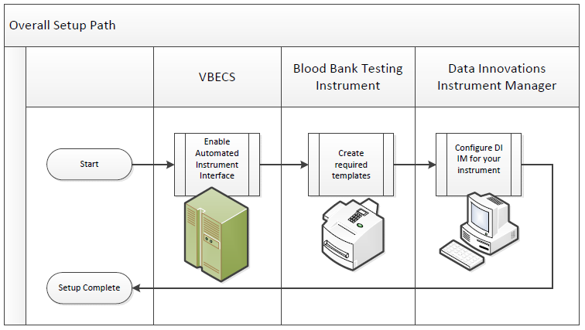

## Related Manuals and Reference Materials

* *VistA Blood Establishment Computer Software (VBECS) Technical Manual-Security Guide*
* *Data Innovations Instrument Manager Manual*
* *Blood Bank Analyzer User’s Guide (Instrument Manual*

# 

# Set Up Automated Instrument

### Network Connectivity Setup

###### In order to ensure a proper functioning of an interface between an Automated Instrument and Instrument Manager the Instrument needs to be connected to the VA network. The static IP Address and Port number has to be assigned to the Instrument (further referred in this document as *<Instrument IP>* and *<Instrument Port>*). Refer to the Instrument Manual or contact your vendor for the instructions about how to perform this setup. Check with Local IT staff to establish the connection to Instrument Manager.

### Testing Profiles Setup

Test results sent using profiles that are not supported will not be accepted in VBECS.



Refer to Appendix E: Vision Testing Profiles for the list of supported instrument profiles. It is up to each blood bank to choose which test profiles will be used as long as they are selected from the list in Appendix E.

AABB Standards require a serological XM to detect ABO incompatibility (5.16.1) and a local policy must be in place if the site is not performing an IS AHG as part of their serologic crossmatch test, manual or using an instrument.



### User ID Setup

Failure to set up proper user IDs on an instrument will prevent instrument results from being accepted in VBECS.



In order for VBECS to properly recognize the person who performed testing on an Instrument, all users accessing the instrument must have their user IDs set up to match their network user IDs (e.g., VHAISHBURNSK).

Refer to the Instrument Manual or contact your vendor for the instructions about how to perform setup of user IDs.

### Manual Versus Automated Review

Vision can be configured to automatically review and send test results to LIS. However, in this configuration the test results are not associated with the name of the person who performed testing on the instrument. VBECS requires that all results sent from an instrument are accompanied by the ID of the user who initiated testing, therefore for the interface to function properly Vision MAY NOT be configured for the full automated review of the results.

The manufacturer recommends that the following configuration is used to ensure that test results are always accompanied by user ID:

**Enforce Manual Review: No**

**Enforce Manual Review for Cards with Error Grades: Yes**

**All Maintenance Tasks must be completed successfully: Yes**

**All column reactions must be without errors: Yes**

**Valid Test Result Interpretation (incl. non-discrepant columns): Yes**

**Above/below positive reaction threshold: Yes**

**Entire order must be completed: No**

Consult user’s manual for the Vision or contact Ortho Diagnostics support if you need help in changing the manual review settings on the instrument.



# Set Up Instrument Manager

### Instrument Manager Version

Verify that you are using Instrument Manager Version 8.13 or greater (Figure 3). In Instrument Manager, navigate to **Help -> About Instrument Manager**.

Figure : Instrument Manager Version Screen

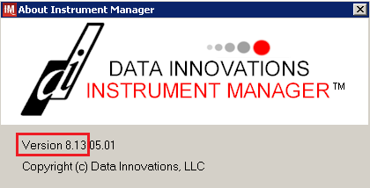

If your version of Instrument Manager is older than 8.13, STOP executing this guide and update the software first. **Do not proceed until the issue is resolved**.



If your Instrument Manager is greater than 8.13 you may proceed. The user must execute the instructions and validate functionality on newer version. Discrepancies in the instructions must be reported as a service request.



Instrument Manager must have the **Specimen Management Module** licensed and activated. **Do not proceed until this issue is resolved**.



### Instrument Manager to Automated Instrument Connectivity

Contact your local network administrative staff and ensure that your local network allows two-way TCP/IP connectivity between ***<Instrument Manager IP>*** address and ***<Instrument IP>*** address on ***<Instrument Port>***.

### Installing Instrument Driver

Two drivers are required for the correct operation of the Automated Instrument interface to VBECS (Figure 4):

Figure 4: Required Drivers

|  |  |  |  |
| --- | --- | --- | --- |
| **Driver** | **Name** | **Version** | **Description** |
| Ortho Vision | ocdvisii | 8.00.0004 | Instrument to DI IM driver |
| Vista VBEC Blood Bank LIS | vadvbecl | 8.00.0001 | DI IM to VBECS (HL7) driver |

*Refer to the user’s manual for Instrument Manager or contact Data Innovations for the instructions on how to install drivers for Instrument Manager.*

After successful installation of drivers go to **Report -> Available Drivers** menu option in Instrument Manager and verify that the drivers listed in Figure 4 are present.

### Set Up Instrument Side Configuration

**Execute instructions in this section for each Vision instrument that will be connecting to VBECS.**



**Modifying rules or test code mappings in the Instrument Manager configuration outside of this Setup Guide is not allowed and may lead to malfunction of the Automated Instrument to VBECS interface.**



Prerequisites for the Instrument Manager Configuration files download:

* You must be an administrator on <***Instrument Manager Server***>.
* Once the above prerequisite is met you may proceed.

#### Download Instrument Configuration Files

**Use local procedures for copying the instrument configuration files to the Instrument Manager server.**



1. Navigate to **http://vaww.oed.portal.va.gov/projects/vbecs/Pages/Instrument-Manager-Configuration-Files-Release.aspx** (Figure 5).

Figure : Connecting to the VBECS SharePoint

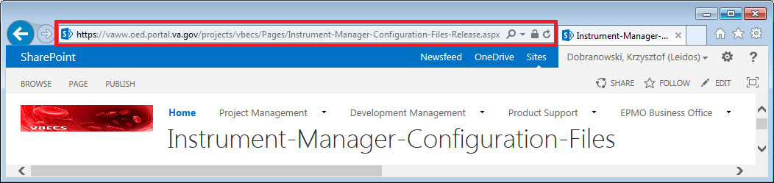

1. To download a file from the SharePoint, right-click on it and select **Save target as** (Figure 6).

Figure : Example of Save target as…

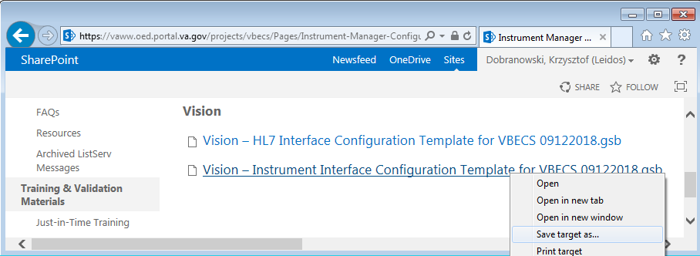

1. In the next screen, specify the directory to save (Figure 7).

Figure : Example of Save As

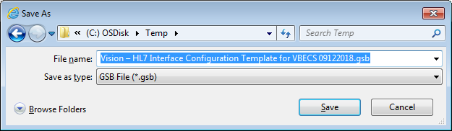

1. Save both the **Vision – HL7 Interface Configuration Template for VBECS 09122018.gsb** and the **Vision – Instrument Interface Configuration Template for VBECS 09122018.gsb** files to the **C:\tem**p directory.
2. Per local procedures, copy both files to **C:\temp** on the Instrument Manager server.
3. On the Instrument Manager server; Click **Start**, and in the “**Search programs and files**” box type **Run** and press **enter**. Type **powershell** and click **OK** to launch PowerShell
4. Copy and paste or type the following commands to generate checksums for configuration files:

**certutil –hashfile “C:\Temp\Vision – HL7 Interface Configuration Template for VBECS 09122018.gsb” MD5 <press Enter>**

**certutil –hashfile “C:\Temp\Vision – Instrument Interface Configuration Template for VBECS 09122018.gsb” MD5 <press Enter>**

**To copy, highlight the lines in grey and enter CTRL-C.**



**To insert the copied line into a PowerShell window, right click in the PowerShell window and select “Paste”.**

1. Verify that checksums for both files match those shown in Figure 8.

Figure : Instrument Manager Configuration File Checksums

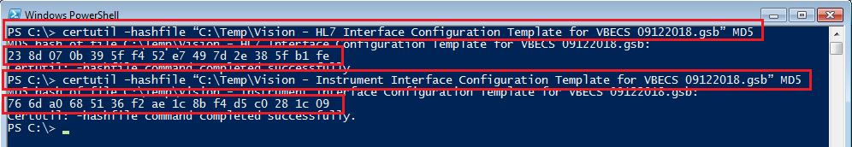

If the checksums do not match, stop and **file a service request to coordinate assistance with installation**. **Do not proceed until the issue is resolved.**



1. Close the **PowerShell** window.

#### Import Instrument Side Configuration

1. After downloading and verifying configuration files, open Instrument Manager and navigate to **Configuration -> Configuration Editor**.
2. Click on the Import button (Figure 9).

Figure : Example of Configuration Editor

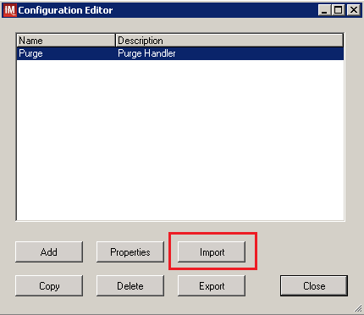

1. Once the import screen opens, click the **Browse** button and select **C:\Temp** folder (Figure 10).
2. Click **OK**.

Figure : Example of Configuration Import Screen

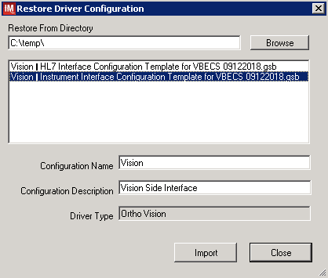

1. Select **Vision – Instrument Interface Configuration Template for VBECS 09122018.gsb** file from the list.
2. Enter **Configuration Name** that contains 3 letter location code of the instrument (e.g., HIN for Hines VAMC), word Vision and sequence number (1 for the first instrument, 2 for the second etc.). Example **Configuration Name** for instrument configuration located at Hines would be:

**HIN_Vision_1**

This configuration name will be further referred in this document as ***<Instrument Side Configuration>***.

1. Enter **Configuration Description** and click **Import** button. Verify that the following confirmation window displays (Figure 11).

Figure : Example of Successful Configuration Import

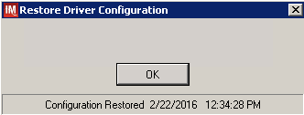

**If you are using newer version of the driver than the one mentioned in section 3, the Instrument Manager will warn you about the discrepancy in driver versions. Acknowledge this warning and continue.**



1. Click **OK** and then close the **Restore Driver Configuration** window.
2. Verify that **Configuration Editor** shows the new configuration on the list (Figure 12).

Figure : Example of Configuration Editor Window Showing Newly Imported Configuration

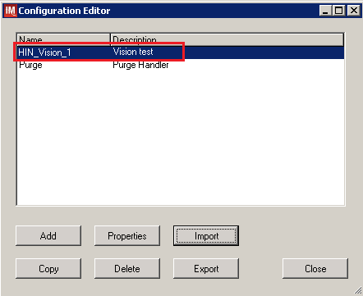

1. Close the Configuration Editor window.

#### Verify Test Code Mapping for Instrument Side Configuration

1. Navigate to **Reports -> Configuration Options and Mappings**.
2. Select the <**Instrument Side Configuration Name**> from the pull-down menu (Figure 13).
3. Select the **Results Test Code Mapping** tab (Figure 13).
4. Verify the **Results Test Code Mapping Report** tab matches the list in- Appendix A: Instrument Side Mapping.

Figure : Example of Results Test Code Mapping Tab

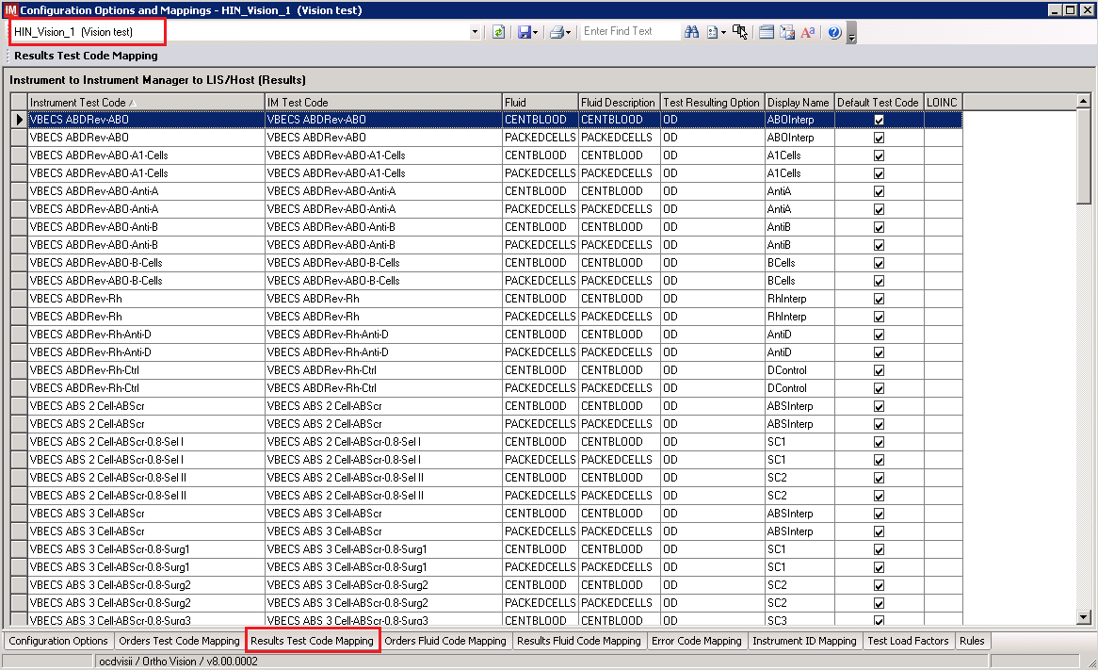

If mismatches in Test Codes names, missing or extra Test Codes are encountered, **file a service request to coordinate assistance with installation.** **Do not proceed until the issue is resolved.**



#### Verify Rules for Instrument Side Configuration

1. Remaining in the Configuration Options and Mapping window, select the **Rules** tab (Figure 14).
2. Verify the **Rules** tab matches the list in Appendix C: Instrument Side Rules.

Figure : Example of Rules Tab

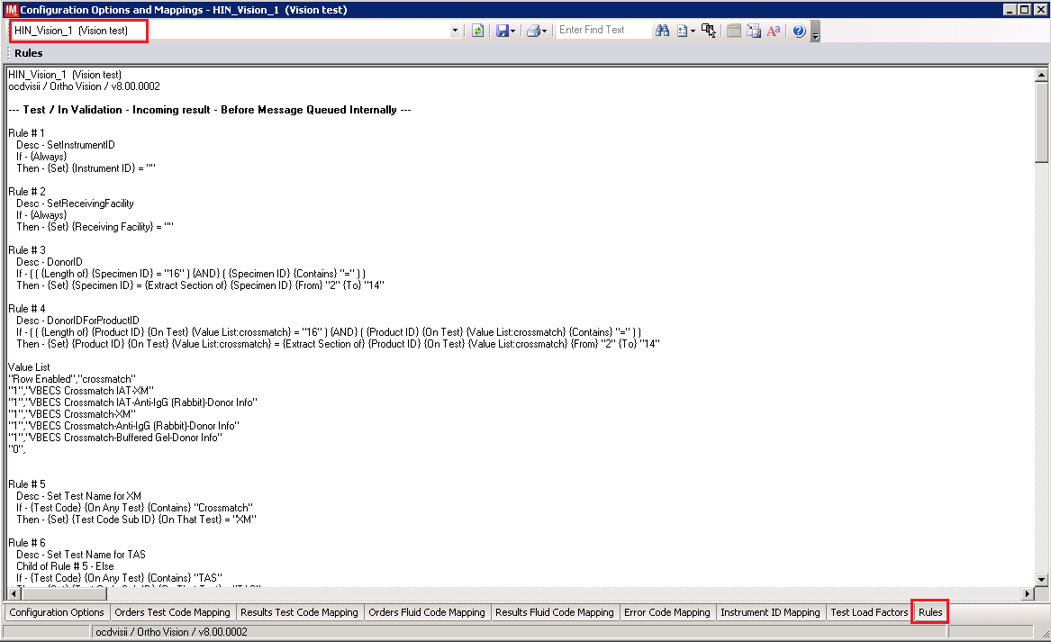

1. Close the Configuration Options and Mappings window.

If problems are encountered, **file a service request to coordinate assistance with installation.** **Do not proceed until the issue is resolved**.



#### Configure Rules for Instrument Side Configuration

In this section your will establish the name of the instrument associated with test results for VBECS reports. *If you are setting up multiple instruments, make sure that each has a unique name.*

1. Navigate to **Configuration -> Specimen Management Configuration -> Rules Processing**.
2. Select <**Instrument Side Configuration Name**> from the pull-down menu (Figure 15).
3. Locate rule **SetInstrumentID**.
4. Click on the **Then** line in the rule.
5. Modify the rule by typing <**Instrument Name**> between the quotation marks in the lower box in (Figure 15).

Figure : Example of Instrument Name Setup

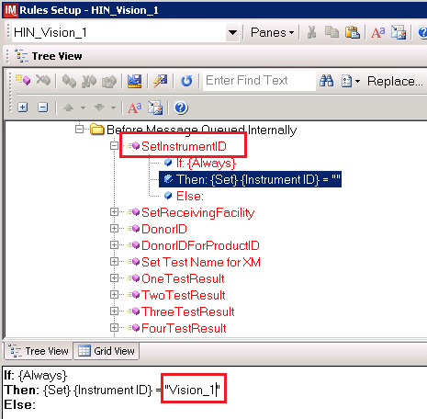

1. Locate rule **SetReceivingFacility**. Click on **Then** line in the rule. Modify the rule by typing <**Division Code**> between the quotation marks as shown in (Figure 16).

**<Division Code>** also known as Station Number in VistA is a unique alphanumeric code that is associated with each hospital (e.g., **589** for VA Heartland West VAMC). This code must match the division code configured in **VBECS Administrator** application for a given site.



Figure : Example of Division Code Setup

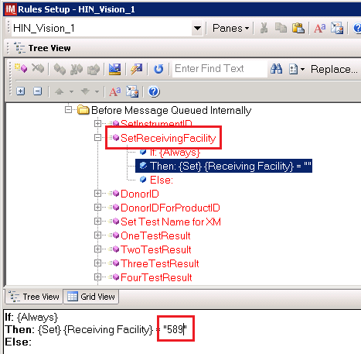

1. Click on the **Save Test / In Validation Rule Set** button located in the toolbar above the rules (Figure 17).

Figure : Example of Save Rules Button



1. Verify that the message in Figure 18 is received:

Figure : Example of Rule Save

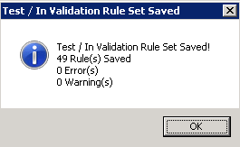

If problems are encountered, **file a service request to coordinate assistance with installation.** **Do not proceed until the issue is resolved.**



1. Click on the **Save Live Rule Set** button located in the upper toolbar and click **Yes** to confirm (Figure 19).

Figure : Example of Save Rules in Live Set Button



1. Navigate to **Reports->Configuration Options and Mappings** and select the **Rules Tab**. Scroll down to **Live – Incoming result – Before Message Queued Internally** (Figure 20).
2. Verify that the Live Rule Set matches Appendix C: Instrument Side Rules and includes changes made to **SetReceivingFacility** and **SetInstrumentID** (Figure 20).

Figure : Example of Live Rules Set View

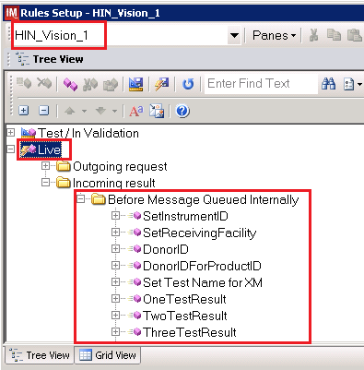

If problems are encountered, **file a service request to coordinate assistance with installation.** **Do not proceed until the issue is resolved.**



1. Close the **Configuration Options and Mappings** window.

#### Import VBECS (HL7) Side Configuration

**Only one HL7 configuration is needed even if you use multiple Vision instruments. All Visions will share the same HL7 configuration.**



**Modifying rules or test code mappings in the Instrument Manager configuration outside of this Setup Guide is not allowed and may lead to malfunction of the Automated Instrument to VBECS interface.**



1. Navigate to **Configuration -> Configuration Editor** (Figure 21).
2. Click on the **Import** button.

Figure : Example of Configuration Editor Window

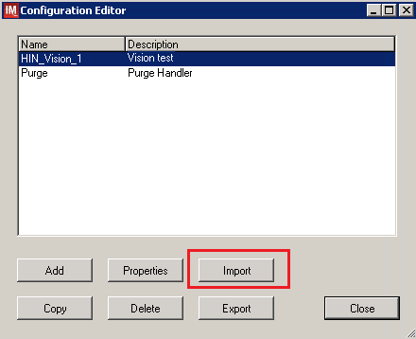

1. Once the **Restore Driver Configuration** window opens, click **Browse** the button and select **C:\Temp** folder (Figure 22).

Figure : Example of Configuration Import Window

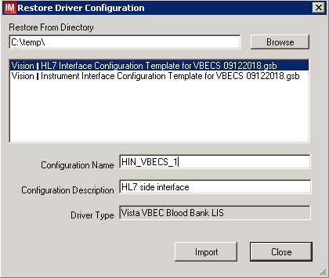

1. Select **Vision – HL7 Interface Configuration Template for VBECS 09122018.gsb** file from the list. Enter **Configuration Name** that contains 3 letter location code of the instrument (e.g., **HIN** for Hines VAMC), word **VBECS** and sequence number (1 for the first configuration, **2** for the second etc.). Example Configuration Name for VBECS side configuration located at Hines would be:

**HIN_VBECS_1**

This configuration name will be further referred in this document as ***<HL7 Side Configuration>***.

1. Enter **Configuration Description** and click **Import** button. Verify that the confirmation window in Figure 23 displays.

Figure : Example of Successful Configuration Import



**If you are using newer version of the driver than the one mentioned in section 3, the Instrument Manager will warn you about the discrepancy in driver versions. Acknowledge this warning and continue.**



1. Click **OK** and close the **Restore Driver Configuration** window.
2. Verify that **Configuration Editor** shows the new configuration on the list (Figure 24).

Figure : Example of Newly Imported HL7 Configuration

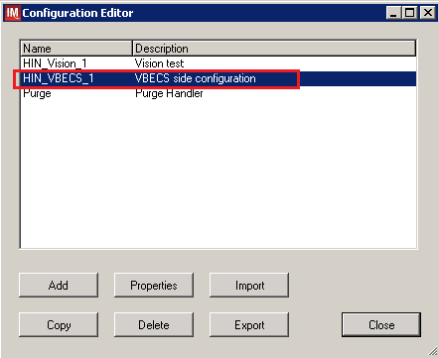

#### Verify Test Code Mapping for VBECS Side Configuration

1. Navigate to **Reports -> Configuration Options and Mappings**.
2. Select the <**HL7 Side Configuration Name**> from the pull-down menu (Figure 25).
3. Select the **Results Test Code Mapping** tab (Figure 25).
4. Verify the **Results Test Code Mapping Report** tab matches the list in Appendix B: HL7 (VBECS) Side Mapping.

Figure : Example of HL7 Configuration Report Window

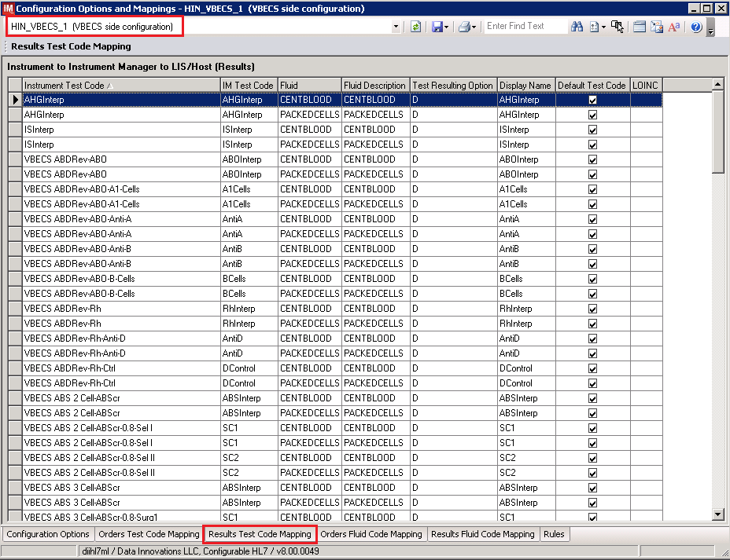

1. Close **Configuration Options and Mappings** window.

If mismatches in Test Codes names, missing or extra Test Codes are encountered, **file a service request to coordinate assistance with installation.** **Do not proceed until the issue is resolved**.



#### Verify Rules for VBECS (HL7) Side Configuration

**Modifying rules or test code mappings in the Instrument Manager configuration outside of this Setup Guide is not allowed and may lead to malfunction of the Automated Instrument to VBECS interface.**



1. Navigate to **Configuration -> Specimen Management Configuration -> Rules Processing**.
2. On the **Rule Processing** window, select <**HL7 Side Configuration**> from the drop-down in the upper left corner.
3. Next, click on the **Quick Filter** icon located on the right side of the **Configuration Name** (Figure 26).

Figure : Example of Rules Processing Toolbar

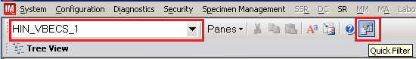

1. On the **Quick Filter** window, check the box next to the **Outgoing Result** and click **Close** button (Figure 27).

Figure : Example of Quick Filter Window

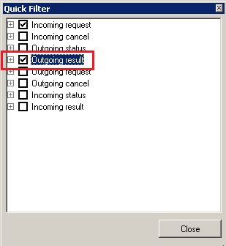

1. Expand **Outgoing Result** section and **Before Message Sent to this Connection** sections (Figure 28).

Figure : Example of Rules Window

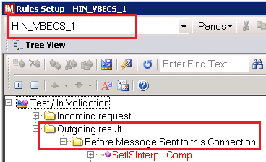

1. Expand all rules and verify that they match rules listed in Appendix D: VBECS (HL7) Side Rules.

If mismatches in rules are encountered, **file a service request to coordinate assistance with installation.** **Do not proceed until the issue is resolved.**



1. Click on the **Save Live Rule Set** button located in the upper toolbar and click **Yes** to confirm (Figure 29).

Figure : Example of Save Rules in Live Set Button



1. Expand the **Live Rule Set** and verify that rule text matches Appendix D: VBECS (HL7) Side Rules. (Figure 30).

Figure : Example of Live Rules Set View

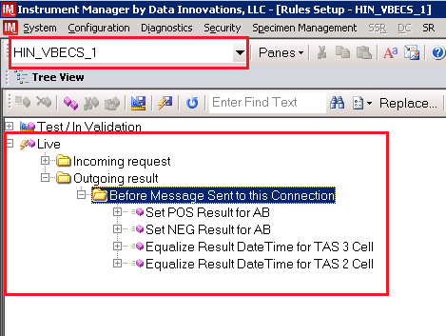

If problems are encountered, **file a service request to coordinate assistance with installation.** **Do not proceed until the issue is resolved**.



1. Close the **Rules Setup** window.

### Set Up HL7 Connection to VBECS TEST

**If you are using multiple Vision instruments they can all share one connection to VBECS.**



**Modifying connection settings in the Instrument Manager outside of this Setup Guide is not allowed and may lead to malfunction of the Automated Instrument to VBECS interface.**



1. Navigate to **Configuration -> Connection Assignment**.
2. On the **Connection Assignment** window, click the **Add** button.
3. On the **Connection Properties** window, enter the **Connection Name**. Enter a name that contains <**HL7 Side Configuration**> and word **Connection**. For example:

**HIN_VBECS_1_Connection**

1. Select <**HL7 Side Configuration**> as **Configuration Name**.
2. Check **Include in Specimen Management** check box.
3. Select **TCP/IP** connection in Device (Figure 31).

Figure : Example of Connection Properties Window

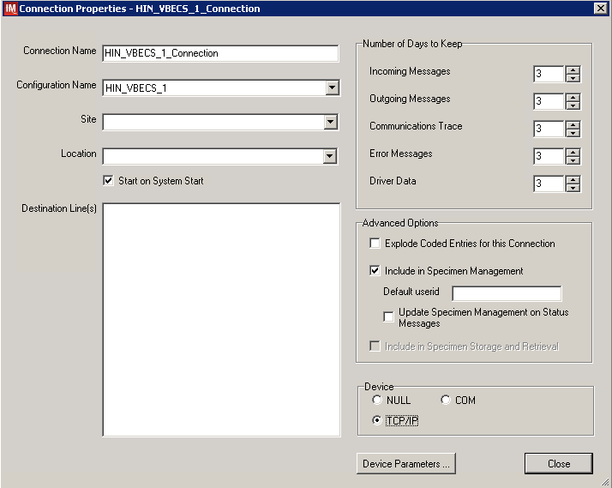

1. Click on **Device Parameters** button.
2. Enter **TCP/IP Address and TCP/IP Port Number** that matches **VBECS TEST Application IP Address and IP Port Number** configured in **VBECS TEST Administrator** application for **Auto Instrument Interface** (Figure 32). Refer to *VistA Blood Establishment Computer Software (VBECS) Technical Manual-Security Guide* for instruction on how to configure interfaces for VBECS.

Figure : Example of TCP/IP Configuration Window

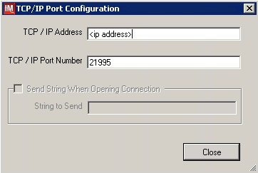

1. Click close on the **TCP/IP Port Configuration** window and click **Yes** to save.
2. Click close on the **Connection Properties** window and click **Yes** to save.
3. Verify the newly created connection shows on **Connection Assignment** window (Figure 33).

Figure : Example of Newly Created Connection

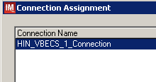

### Set Up Instrument Connection

**Execute instructions in this section for each instrument that will be connecting to VBECS.**



**Modifying connection settings in the Instrument Manager outside of this Setup Guide is not allowed and may lead to malfunction of the Automated Instrument to VBECS interface.**



1. On the **Connection Assignment** window, click the **Add** button.
2. On the **Connection Properties** window, enter the **Connection Name**. Enter a name that contains <**Instrument Side Configuration**> and word **Connection**. For example:

**HIN_Vision_1_Connection**

1. Select <**Instrument Side Configuration**> **as Configuration Name**.
2. Check **Include** in **Specimen Management** check box.
3. Select **TCP/IP** connection.
4. On the **Destination Lines** list, check the box next to connection configured in previous section (Figure 34).

Figure : Example of Connection Properties Window

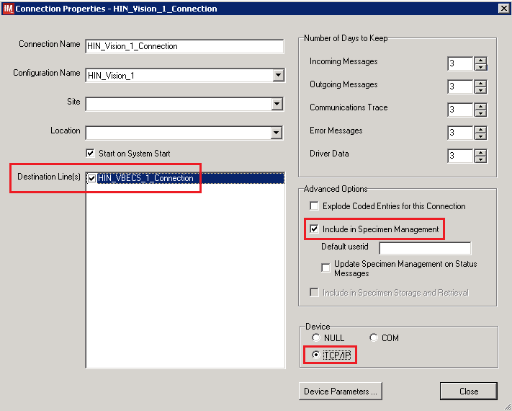

1. Click on **Device Parameters** button.
2. **TCP/IP Address** remains blank.
3. Set **TCP/IP Port Number** to <**Instrument Port**> discussed in Section **Network Connectivity Setup**.
4. Uncheck **Send String When Opening Connection** check box (Figure 35).

Figure : Example of TCP/IP Configuration Window

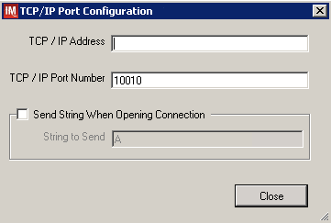

1. Click **Close** on the **TCP/IP Port Configuration** window and click **Yes** to save.
2. Click **Close** on the **Connection Properties** window and click **Yes** to save.
3. Verify the newly created connection shows on **Connection Assignment** window (Figure 36).
4. Close the **Connection Assignment** window.

Figure : Example of Newly Created Connection

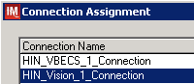

### Test New Connections

1. Navigate to **System -> Status**.
2. Right-click each newly created connection and choose option to **Start Selected Connections** (Figure 37).

Figure : Example of Connection Status Window

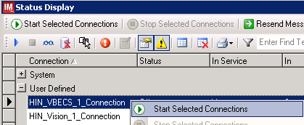

1. Verify that all newly created connections are showing **Status** of **On** after about a minute or so (Figure 38).

Figure : Example of Successful Connection Test

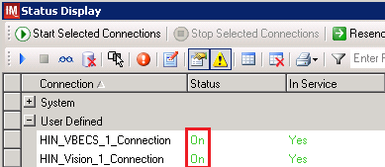

If one or more connections fail to start, **file a service request to coordinate assistance with installation.** **Do not proceed until the issue is resolved.**



1. Close the **Status Display**.

### Validate Instrument Connectivity to VBECS TEST

Execute validation instructions from Appendix F: Validation Planning and Example Test Scenarios to verify that Instrument is properly interfacing with VBECS.

If one or more validation scenarios fail, **file a service request to coordinate assistance with installation.** **Do not proceed until the issue is resolved.**



### Set Up HL7 Connection to VBECS PROD

1. Navigate to **System -> Status**.
2. Right-click <**VBECS_Connection**> and choose option to **Stop Selected Connections** (Figure 39).

Figure : Example of Stop Selected Connections

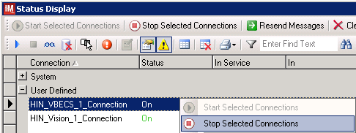

1. Wait until connection status changes to **Off**. Navigate to **Configuration -> Connection Assignment**.
2. Select <**VBECS_Connection**> and click **Properties** (Figure 40).

Figure : Example of Connection Assignment

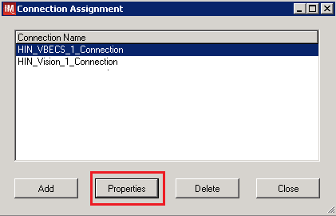

1. On **Connection Properties** window click **Device Parameters** (Figure 41).

Figure : Example of Connection Properties

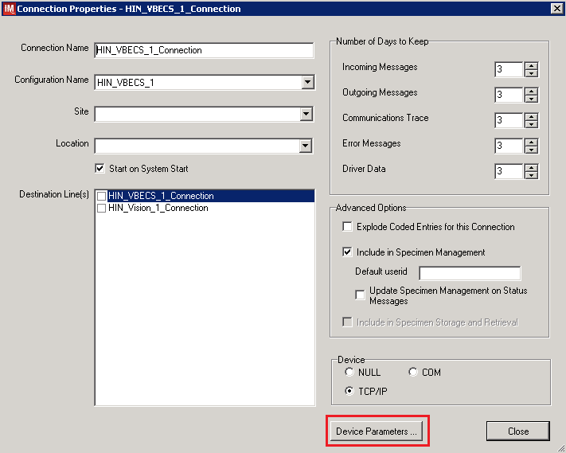

1. Enter **TCP/IP Address and TCP/IP Port Number** that matches **VBECS PROD Application IP Address and IP Port Number** configured in **VBECS PROD Administrator** application for **Auto Instrument Interface** (Figure 42). Refer to VistA Blood Establishment Computer Software (VBECS) Technical Manual-Security Guide for instruction on how to configure interfaces for VBECS.

Figure : Example of TCP/IP Configuration Window

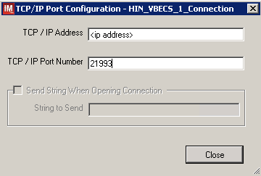

1. Close the **TCP/IP Port Configuration** and click **Yes** to confirm changes.
2. Close the **Connection Properties** window and click **Yes** to confirm changes.
3. Close the **Connection Assignment** window.
4. Navigate to **System -> Status**.
5. Right-click <**VBECS_Connection**> and choose option to **Start Selected Connections** (Figure 43).

Figure : Example of Connection Status Window



1. Verify that <**VBECS_Connection**> is showing **Status** of **On** after about a minute or so (Figure 44).

Figure : Example of Successful Connection Test



If connection fails to start, **file a service request to coordinate assistance with installation.** **Do not proceed until the issue is resolved.**



1. Close the **Status Display** and log off the system.

Glossary

| **Acronym, Term** | **Definition** |
| --- | --- |
| **Automated Instrument** | Blood Bank Analyzer that performs blood testing. |
| **Division Code** | Also known as Station Number in Vista is the unique alphanumeric code that is associated with each hospital (e.g., 589 for VA Heartland West). |
| **Instrument Manager (IM)** | Software created by Data Innovations that serves as a middleware between Automated Instrument and VBECS. It translates messages containing test results sent from an instrument into HL7 messages that are then parsed into VBECS. |
| **VA** | Department of Veterans Affairs. |
| **VBECS** | VistA Blood Establishment Computer Software. |
| **VistA** | Veterans Health Information Systems and Technology Architecture. VistA software, developed by the VA, is used to support clinical and administrative functions at VA Medical Centers nationwide. VistA is composed of packages that undergo a verification process to ensure conformity with name spacing and other VistA standards and conventions. |

# Appendices

## Appendix A: Instrument Side Mapping

Table - Appendix A: Instrument Side Mapping

| **Instrument Test Code** | **IM Test Code** | **Fluid** | **Display Name** |
| --- | --- | --- | --- |
| VBECS ABDRev-ABO | VBECS ABDRev-ABO | PACKEDCELLS | ABOInterp |
| VBECS ABDRev-ABO | VBECS ABDRev-ABO | CENTBLOOD | ABOInterp |
| VBECS ABDRev-ABO-A1-Cells | VBECS ABDRev-ABO-A1-Cells | PACKEDCELLS | A1Cells |
| VBECS ABDRev-ABO-A1-Cells | VBECS ABDRev-ABO-A1-Cells | CENTBLOOD | A1Cells |
| VBECS ABDRev-ABO-Anti-A | VBECS ABDRev-ABO-Anti-A | PACKEDCELLS | AntiA |
| VBECS ABDRev-ABO-Anti-A | VBECS ABDRev-ABO-Anti-A | CENTBLOOD | AntiA |
| VBECS ABDRev-ABO-Anti-B | VBECS ABDRev-ABO-Anti-B | PACKEDCELLS | AntiB |
| VBECS ABDRev-ABO-Anti-B | VBECS ABDRev-ABO-Anti-B | CENTBLOOD | AntiB |
| VBECS ABDRev-ABO-B-Cells | VBECS ABDRev-ABO-B-Cells | PACKEDCELLS | BCells |
| VBECS ABDRev-ABO-B-Cells | VBECS ABDRev-ABO-B-Cells | CENTBLOOD | BCells |
| VBECS ABDRev-Rh | VBECS ABDRev-Rh | PACKEDCELLS | RhInterp |
| VBECS ABDRev-Rh | VBECS ABDRev-Rh | CENTBLOOD | RhInterp |
| VBECS ABDRev-Rh-Anti-D | VBECS ABDRev-Rh-Anti-D | PACKEDCELLS | AntiD |
| VBECS ABDRev-Rh-Anti-D | VBECS ABDRev-Rh-Anti-D | CENTBLOOD | AntiD |
| VBECS ABDRev-Rh-Ctrl | VBECS ABDRev-Rh-Ctrl | PACKEDCELLS | DControl |
| VBECS ABDRev-Rh-Ctrl | VBECS ABDRev-Rh-Ctrl | CENTBLOOD | DControl |
| VBECS ABS 2 Cell-ABScr | VBECS ABS 2 Cell-ABScr | PACKEDCELLS | ABSInterp |
| VBECS ABS 2 Cell-ABScr | VBECS ABS 2 Cell-ABScr | CENTBLOOD | ABSInterp |
| VBECS ABS 2 Cell-ABScr-0.8-Sel I | VBECS ABS 2 Cell-ABScr-0.8-Sel I | PACKEDCELLS | SC1 |
| VBECS ABS 2 Cell-ABScr-0.8-Sel I | VBECS ABS 2 Cell-ABScr-0.8-Sel I | CENTBLOOD | SC1 |
| VBECS ABS 2 Cell-ABScr-0.8-Sel II | VBECS ABS 2 Cell-ABScr-0.8-Sel II | PACKEDCELLS | SC2 |
| VBECS ABS 2 Cell-ABScr-0.8-Sel II | VBECS ABS 2 Cell-ABScr-0.8-Sel II | CENTBLOOD | SC2 |
| VBECS ABS 3 Cell-ABScr | VBECS ABS 3 Cell-ABScr | PACKEDCELLS | ABSInterp |
| VBECS ABS 3 Cell-ABScr | VBECS ABS 3 Cell-ABScr | CENTBLOOD | ABSInterp |
| VBECS ABS 3 Cell-ABScr-0.8-Surg1 | VBECS ABS 3 Cell-ABScr-0.8-Surg1 | PACKEDCELLS | SC1 |
| VBECS ABS 3 Cell-ABScr-0.8-Surg1 | VBECS ABS 3 Cell-ABScr-0.8-Surg1 | CENTBLOOD | SC1 |
| VBECS ABS 3 Cell-ABScr-0.8-Surg2 | VBECS ABS 3 Cell-ABScr-0.8-Surg2 | PACKEDCELLS | SC2 |
| VBECS ABS 3 Cell-ABScr-0.8-Surg2 | VBECS ABS 3 Cell-ABScr-0.8-Surg2 | CENTBLOOD | SC2 |
| VBECS ABS 3 Cell-ABScr-0.8-Surg3 | VBECS ABS 3 Cell-ABScr-0.8-Surg3 | PACKEDCELLS | SC3 |
| VBECS ABS 3 Cell-ABScr-0.8-Surg3 | VBECS ABS 3 Cell-ABScr-0.8-Surg3 | CENTBLOOD | SC3 |
| VBECS Confirm AB-ABO | VBECS Confirm AB-ABO | PACKEDCELLS | ABOInterp |
| VBECS Confirm AB-ABO | VBECS Confirm AB-ABO | CENTBLOOD | ABOInterp |
| VBECS Confirm AB-ABO-Anti-A | VBECS Confirm AB-ABO-Anti-A | PACKEDCELLS | AntiA |
| VBECS Confirm AB-ABO-Anti-A | VBECS Confirm AB-ABO-Anti-A | CENTBLOOD | AntiA |
| VBECS Confirm AB-ABO-Anti-B | VBECS Confirm AB-ABO-Anti-B | PACKEDCELLS | AntiB |
| VBECS Confirm AB-ABO-Anti-B | VBECS Confirm AB-ABO-Anti-B | CENTBLOOD | AntiB |
| VBECS Confirm ABD-ABO | VBECS Confirm ABD-ABO | PACKEDCELLS | ABOInterp |
| VBECS Confirm ABD-ABO | VBECS Confirm ABD-ABO | CENTBLOOD | ABOInterp |
| VBECS Confirm ABD-ABO-Anti-A | VBECS Confirm ABD-ABO-Anti-A | PACKEDCELLS | AntiA |
| VBECS Confirm ABD-ABO-Anti-A | VBECS Confirm ABD-ABO-Anti-A | CENTBLOOD | AntiA |
| VBECS Confirm ABD-ABO-Anti-B | VBECS Confirm ABD-ABO-Anti-B | PACKEDCELLS | AntiB |
| VBECS Confirm ABD-ABO-Anti-B | VBECS Confirm ABD-ABO-Anti-B | CENTBLOOD | AntiB |
| VBECS Confirm ABD-Rh | VBECS Confirm ABD-Rh | PACKEDCELLS | RhInterp |
| VBECS Confirm ABD-Rh | VBECS Confirm ABD-Rh | CENTBLOOD | RhInterp |
| VBECS Confirm ABD-Rh-Anti-D | VBECS Confirm ABD-Rh-Anti-D | PACKEDCELLS | AntiD |
| VBECS Confirm ABD-Rh-Anti-D | VBECS Confirm ABD-Rh-Anti-D | CENTBLOOD | AntiD |
| VBECS Confirm O Neg-Anti-AB | VBECS Confirm O Neg-Anti-AB | PACKEDCELLS | ABOInterp |
| VBECS Confirm O Neg-Anti-AB | VBECS Confirm O Neg-Anti-AB | CENTBLOOD | ABOInterp |
| VBECS Confirm O Neg-Anti-AB-Anti-A+B | VBECS Confirm O Neg-Anti-AB-Anti-A+B | PACKEDCELLS | AntiAB |
| VBECS Confirm O Neg-Anti-AB-Anti-A+B | VBECS Confirm O Neg-Anti-AB-Anti-A+B | CENTBLOOD | AntiAB |
| VBECS Confirm O Neg-Rh | VBECS Confirm O Neg-Rh | PACKEDCELLS | RhInterp |
| VBECS Confirm O Neg-Rh | VBECS Confirm O Neg-Rh | CENTBLOOD | RhInterp |
| VBECS Confirm O Neg-Rh-Anti-D | VBECS Confirm O Neg-Rh-Anti-D | PACKEDCELLS | AntiD |
| VBECS Confirm O Neg-Rh-Anti-D | VBECS Confirm O Neg-Rh-Anti-D | CENTBLOOD | AntiD |
| VBECS Confirm O Pos-Anti-AB | VBECS Confirm O Pos-Anti-AB | PACKEDCELLS | ABOInterp |
| VBECS Confirm O Pos-Anti-AB | VBECS Confirm O Pos-Anti-AB | CENTBLOOD | ABOInterp |
| VBECS Confirm O Pos-Anti-AB-Anti-A+B | VBECS Confirm O Pos-Anti-AB-Anti-A+B | PACKEDCELLS | AntiAB |
| VBECS Confirm O Pos-Anti-AB-Anti-A+B | VBECS Confirm O Pos-Anti-AB-Anti-A+B | CENTBLOOD | AntiAB |
| VBECS Crossmatch IAT-Anti-IgG (Rabbit)-Donor Info | VBECS Crossmatch IAT-Anti-IgG (Rabbit)-Donor Info | PACKEDCELLS | AHG |
| VBECS Crossmatch IAT-Anti-IgG (Rabbit)-Donor Info | VBECS Crossmatch IAT-Anti-IgG (Rabbit)-Donor Info | CENTBLOOD | AHG |
| VBECS Crossmatch IAT-XM-Anti-IgG (Rabbit) | VBECS Crossmatch IAT-XM-Anti-IgG (Rabbit) | PACKEDCELLS | XMInterp |
| VBECS Crossmatch IAT-XM-Anti-IgG (Rabbit) | VBECS Crossmatch IAT-XM-Anti-IgG (Rabbit) | CENTBLOOD | XMInterp |
| VBECS Crossmatch-Anti-IgG (Rabbit)-Donor Info | VBECS Crossmatch-Anti-IgG (Rabbit)-Donor Info | PACKEDCELLS | AHG |
| VBECS Crossmatch-Anti-IgG (Rabbit)-Donor Info | VBECS Crossmatch-Anti-IgG (Rabbit)-Donor Info | CENTBLOOD | AHG |
| VBECS Crossmatch-Buffered Gel-Donor Info | VBECS Crossmatch-Buffered Gel-Donor Info | PACKEDCELLS | IS |
| VBECS Crossmatch-Buffered Gel-Donor Info | VBECS Crossmatch-Buffered Gel-Donor Info | CENTBLOOD | IS |
| VBECS Crossmatch-XM-Anti-IgG (Rabbit) | VBECS Crossmatch-XM-Anti-IgG (Rabbit) | PACKEDCELLS | AHGInterp |
| VBECS Crossmatch-XM-Anti-IgG (Rabbit) | VBECS Crossmatch-XM-Anti-IgG (Rabbit) | CENTBLOOD | AHGInterp |
| VBECS Crossmatch-XM-Buffered Gel | VBECS Crossmatch-XM-Buffered Gel | PACKEDCELLS | ISInterp |
| VBECS Crossmatch-XM-Buffered Gel | VBECS Crossmatch-XM-Buffered Gel | CENTBLOOD | ISInterp |
| VBECS DAT IgG-IgG | VBECS DAT IgG-IgG | PACKEDCELLS | IgGInterp |
| VBECS DAT IgG-IgG | VBECS DAT IgG-IgG | CENTBLOOD | IgGInterp |
| VBECS DAT IgG-IgG-IgG | VBECS DAT IgG-IgG-IgG | PACKEDCELLS | IgG |
| VBECS DAT IgG-IgG-IgG | VBECS DAT IgG-IgG-IgG | CENTBLOOD | IgG |
| VBECS DAT Poly+IgG-IgG | VBECS DAT Poly+IgG-IgG | PACKEDCELLS | IgGInterp |
| VBECS DAT Poly+IgG-IgG | VBECS DAT Poly+IgG-IgG | CENTBLOOD | IgGInterp |
| VBECS DAT Poly+IgG-IgG-IgG | VBECS DAT Poly+IgG-IgG-IgG | PACKEDCELLS | IgG |
| VBECS DAT Poly+IgG-IgG-IgG | VBECS DAT Poly+IgG-IgG-IgG | CENTBLOOD | IgG |
| VBECS DAT Poly+IgG-Poly | VBECS DAT Poly+IgG-Poly | PACKEDCELLS | DATInterp |
| VBECS DAT Poly+IgG-Poly | VBECS DAT Poly+IgG-Poly | CENTBLOOD | DATInterp |
| VBECS DAT Poly+IgG-Poly-Poly | VBECS DAT Poly+IgG-Poly-Poly | PACKEDCELLS | AHG |
| VBECS DAT Poly+IgG-Poly-Poly | VBECS DAT Poly+IgG-Poly-Poly | CENTBLOOD | AHG |
| VBECS DAT-Poly | VBECS DAT-Poly | PACKEDCELLS | DATInterp |
| VBECS DAT-Poly | VBECS DAT-Poly | CENTBLOOD | DATInterp |
| VBECS DAT-Poly-Poly | VBECS DAT-Poly-Poly | PACKEDCELLS | AHG |
| VBECS DAT-Poly-Poly | VBECS DAT-Poly-Poly | CENTBLOOD | AHG |
| VBECS Phenotyping C-Anti-C (RH2) | VBECS Phenotyping C-Anti-C (RH2) | PACKEDCELLS | CInterp |
| VBECS Phenotyping C-Anti-C (RH2) | VBECS Phenotyping C-Anti-C (RH2) | CENTBLOOD | CInterp |
| VBECS Phenotyping C-Anti-C (RH2)-Anti-C (RH2) | VBECS Phenotyping C-Anti-C (RH2)-Anti-C (RH2) | PACKEDCELLS | Anti-C |
| VBECS Phenotyping C-Anti-C (RH2)-Anti-C (RH2) | VBECS Phenotyping C-Anti-C (RH2)-Anti-C (RH2) | CENTBLOOD | Anti-C |
| VBECS Phenotyping E-Anti-E (RH3) | VBECS Phenotyping E-Anti-E (RH3) | PACKEDCELLS | EInterp |
| VBECS Phenotyping E-Anti-E (RH3) | VBECS Phenotyping E-Anti-E (RH3) | CENTBLOOD | EInterp |
| VBECS Phenotyping E-Anti-E (RH3)-Anti-E (RH3) | VBECS Phenotyping E-Anti-E (RH3)-Anti-E (RH3) | PACKEDCELLS | Anti-E |
| VBECS Phenotyping E-Anti-E (RH3)-Anti-E (RH3) | VBECS Phenotyping E-Anti-E (RH3)-Anti-E (RH3) | CENTBLOOD | Anti-E |
| VBECS Phenotyping smc-Anti-c (RH4) | VBECS Phenotyping smc-Anti-c (RH4) | PACKEDCELLS | cInterp |
| VBECS Phenotyping smc-Anti-c (RH4) | VBECS Phenotyping smc-Anti-c (RH4) | CENTBLOOD | cInterp |
| VBECS Phenotyping smc-Anti-c (RH4)-Anti-c (RH4) | VBECS Phenotyping smc-Anti-c (RH4)-Anti-c (RH4) | PACKEDCELLS | Anti-c |
| VBECS Phenotyping smc-Anti-c (RH4)-Anti-c (RH4) | VBECS Phenotyping smc-Anti-c (RH4)-Anti-c (RH4) | CENTBLOOD | Anti-c |
| VBECS Phenotyping sme-Anti-e (RH5) | VBECS Phenotyping sme-Anti-e (RH5) | PACKEDCELLS | eInterp |
| VBECS Phenotyping sme-Anti-e (RH5) | VBECS Phenotyping sme-Anti-e (RH5) | CENTBLOOD | eInterp |
| VBECS Phenotyping sme-Anti-e (RH5)-Anti-e (RH5) | VBECS Phenotyping sme-Anti-e (RH5)-Anti-e (RH5) | PACKEDCELLS | Anti-e |
| VBECS Phenotyping sme-Anti-e (RH5)-Anti-e (RH5) | VBECS Phenotyping sme-Anti-e (RH5)-Anti-e (RH5) | CENTBLOOD | Anti-e |
| VBECS Rh Phenotype-Pheno | VBECS Rh Phenotype-Pheno | PACKEDCELLS | RhPhenoInterp |
| VBECS Rh Phenotype-Pheno | VBECS Rh Phenotype-Pheno | CENTBLOOD | RhPhenoInterp |
| VBECS Rh Phenotype-Pheno-Anti-C (RH2) | VBECS Rh Phenotype-Pheno-Anti-C (RH2) | PACKEDCELLS | Anti-C |
| VBECS Rh Phenotype-Pheno-Anti-C (RH2) | VBECS Rh Phenotype-Pheno-Anti-C (RH2) | CENTBLOOD | Anti-C |
| VBECS Rh Phenotype-Pheno-Anti-c (RH4) | VBECS Rh Phenotype-Pheno-Anti-c (RH4) | CENTBLOOD | Anti-c |
| VBECS Rh Phenotype-Pheno-Anti-c (RH4) | VBECS Rh Phenotype-Pheno-Anti-c (RH4) | PACKEDCELLS | Anti-c |
| VBECS Rh Phenotype-Pheno-Anti-E (RH3) | VBECS Rh Phenotype-Pheno-Anti-E (RH3) | CENTBLOOD | Anti-E |
| VBECS Rh Phenotype-Pheno-Anti-E (RH3) | VBECS Rh Phenotype-Pheno-Anti-E (RH3) | PACKEDCELLS | Anti-E |
| VBECS Rh Phenotype-Pheno-Anti-e (RH5) | VBECS Rh Phenotype-Pheno-Anti-e (RH5) | PACKEDCELLS | Anti-e |
| VBECS Rh Phenotype-Pheno-Anti-e (RH5) | VBECS Rh Phenotype-Pheno-Anti-e (RH5) | CENTBLOOD | Anti-e |
| VBECS TAS 2 Cell-ABO | VBECS TAS 2 Cell-ABO | PACKEDCELLS | ABOInterp |
| VBECS TAS 2 Cell-ABO | VBECS TAS 2 Cell-ABO | CENTBLOOD | ABOInterp |
| VBECS TAS 2 Cell-ABO-A1-Cells | VBECS TAS 2 Cell-ABO-A1-Cells | PACKEDCELLS | A1Cells |
| VBECS TAS 2 Cell-ABO-A1-Cells | VBECS TAS 2 Cell-ABO-A1-Cells | CENTBLOOD | A1Cells |
| VBECS TAS 2 Cell-ABO-Anti-A | VBECS TAS 2 Cell-ABO-Anti-A | PACKEDCELLS | AntiA |
| VBECS TAS 2 Cell-ABO-Anti-A | VBECS TAS 2 Cell-ABO-Anti-A | CENTBLOOD | AntiA |
| VBECS TAS 2 Cell-ABO-Anti-B | VBECS TAS 2 Cell-ABO-Anti-B | PACKEDCELLS | AntiB |
| VBECS TAS 2 Cell-ABO-Anti-B | VBECS TAS 2 Cell-ABO-Anti-B | CENTBLOOD | AntiB |
| VBECS TAS 2 Cell-ABO-B-Cells | VBECS TAS 2 Cell-ABO-B-Cells | PACKEDCELLS | BCells |
| VBECS TAS 2 Cell-ABO-B-Cells | VBECS TAS 2 Cell-ABO-B-Cells | CENTBLOOD | BCells |
| VBECS TAS 2 Cell-ABScr | VBECS TAS 2 Cell-ABScr | PACKEDCELLS | ABSInterp |
| VBECS TAS 2 Cell-ABScr | VBECS TAS 2 Cell-ABScr | CENTBLOOD | ABSInterp |
| VBECS TAS 2 Cell-ABScr-0.8-Sel I | VBECS TAS 2 Cell-ABScr-0.8-Sel I | PACKEDCELLS | SC1 |
| VBECS TAS 2 Cell-ABScr-0.8-Sel I | VBECS TAS 2 Cell-ABScr-0.8-Sel I | CENTBLOOD | SC1 |
| VBECS TAS 2 Cell-ABScr-0.8-Sel II | VBECS TAS 2 Cell-ABScr-0.8-Sel II | PACKEDCELLS | SC2 |
| VBECS TAS 2 Cell-ABScr-0.8-Sel II | VBECS TAS 2 Cell-ABScr-0.8-Sel II | CENTBLOOD | SC2 |
| VBECS TAS 2 Cell-Rh | VBECS TAS 2 Cell-Rh | PACKEDCELLS | RhInterp |
| VBECS TAS 2 Cell-Rh | VBECS TAS 2 Cell-Rh | CENTBLOOD | RhInterp |
| VBECS TAS 2 Cell-Rh-Anti-D | VBECS TAS 2 Cell-Rh-Anti-D | PACKEDCELLS | AntiD |
| VBECS TAS 2 Cell-Rh-Anti-D | VBECS TAS 2 Cell-Rh-Anti-D | CENTBLOOD | AntiD |
| VBECS TAS 2 Cell-Rh-Ctrl | VBECS TAS 2 Cell-Rh-Ctrl | PACKEDCELLS | DControl |
| VBECS TAS 2 Cell-Rh-Ctrl | VBECS TAS 2 Cell-Rh-Ctrl | CENTBLOOD | DControl |
| VBECS TAS 3 Cell-ABO | VBECS TAS 3 Cell-ABO | PACKEDCELLS | ABOInterp |
| VBECS TAS 3 Cell-ABO | VBECS TAS 3 Cell-ABO | CENTBLOOD | ABOInterp |
| VBECS TAS 3 Cell-ABO-A1-Cells | VBECS TAS 3 Cell-ABO-A1-Cells | PACKEDCELLS | A1Cells |
| VBECS TAS 3 Cell-ABO-A1-Cells | VBECS TAS 3 Cell-ABO-A1-Cells | CENTBLOOD | A1Cells |
| VBECS TAS 3 Cell-ABO-Anti-A | VBECS TAS 3 Cell-ABO-Anti-A | PACKEDCELLS | AntiA |
| VBECS TAS 3 Cell-ABO-Anti-A | VBECS TAS 3 Cell-ABO-Anti-A | CENTBLOOD | AntiA |
| VBECS TAS 3 Cell-ABO-Anti-B | VBECS TAS 3 Cell-ABO-Anti-B | PACKEDCELLS | AntiB |
| VBECS TAS 3 Cell-ABO-Anti-B | VBECS TAS 3 Cell-ABO-Anti-B | CENTBLOOD | AntiB |
| VBECS TAS 3 Cell-ABO-B-Cells | VBECS TAS 3 Cell-ABO-B-Cells | PACKEDCELLS | BCells |
| VBECS TAS 3 Cell-ABO-B-Cells | VBECS TAS 3 Cell-ABO-B-Cells | CENTBLOOD | BCells |
| VBECS TAS 3 Cell-ABScr | VBECS TAS 3 Cell-ABScr | PACKEDCELLS | ABSInterp |
| VBECS TAS 3 Cell-ABScr | VBECS TAS 3 Cell-ABScr | CENTBLOOD | ABSInterp |
| VBECS TAS 3 Cell-ABScr-0.8-Surg1 | VBECS TAS 3 Cell-ABScr-0.8-Surg1 | PACKEDCELLS | SC1 |
| VBECS TAS 3 Cell-ABScr-0.8-Surg1 | VBECS TAS 3 Cell-ABScr-0.8-Surg1 | CENTBLOOD | SC1 |
| VBECS TAS 3 Cell-ABScr-0.8-Surg2 | VBECS TAS 3 Cell-ABScr-0.8-Surg2 | PACKEDCELLS | SC2 |
| VBECS TAS 3 Cell-ABScr-0.8-Surg2 | VBECS TAS 3 Cell-ABScr-0.8-Surg2 | CENTBLOOD | SC2 |
| VBECS TAS 3 Cell-ABScr-0.8-Surg3 | VBECS TAS 3 Cell-ABScr-0.8-Surg3 | PACKEDCELLS | SC3 |
| VBECS TAS 3 Cell-ABScr-0.8-Surg3 | VBECS TAS 3 Cell-ABScr-0.8-Surg3 | CENTBLOOD | SC3 |
| VBECS TAS 3 Cell-Rh | VBECS TAS 3 Cell-Rh | PACKEDCELLS | RhInterp |
| VBECS TAS 3 Cell-Rh | VBECS TAS 3 Cell-Rh | CENTBLOOD | RhInterp |
| VBECS TAS 3 Cell-Rh-Anti-D | VBECS TAS 3 Cell-Rh-Anti-D | PACKEDCELLS | AntiD |
| VBECS TAS 3 Cell-Rh-Anti-D | VBECS TAS 3 Cell-Rh-Anti-D | CENTBLOOD | AntiD |
| VBECS TAS 3 Cell-Rh-Ctrl | VBECS TAS 3 Cell-Rh-Ctrl | PACKEDCELLS | DControl |
| VBECS TAS 3 Cell-Rh-Ctrl | VBECS TAS 3 Cell-Rh-Ctrl | CENTBLOOD | DControl |

## Appendix B: HL7 (VBECS) Side Mapping

Table - Appendix B: HL7 (VBECS) Side Mapping

| **Instrument Test Code** | **IM Test Code** | **Fluid** |
| --- | --- | --- |
| VBECS ABDRev-ABO | ABOInterp | PACKEDCELLS |
| VBECS ABDRev-ABO | ABOInterp | CENTBLOOD |
| VBECS ABDRev-ABO-A1-Cells | A1Cells | PACKEDCELLS |
| VBECS ABDRev-ABO-A1-Cells | A1Cells | CENTBLOOD |
| VBECS ABDRev-ABO-Anti-A | AntiA | PACKEDCELLS |
| VBECS ABDRev-ABO-Anti-A | AntiA | CENTBLOOD |
| VBECS ABDRev-ABO-Anti-B | AntiB | PACKEDCELLS |
| VBECS ABDRev-ABO-Anti-B | AntiB | CENTBLOOD |
| VBECS ABDRev-ABO-B-Cells | BCells | PACKEDCELLS |
| VBECS ABDRev-ABO-B-Cells | BCells | CENTBLOOD |
| VBECS ABDRev-Rh | RhInterp | PACKEDCELLS |
| VBECS ABDRev-Rh | RhInterp | CENTBLOOD |
| VBECS ABDRev-Rh-Anti-D | AntiD | PACKEDCELLS |
| VBECS ABDRev-Rh-Anti-D | AntiD | CENTBLOOD |
| VBECS ABDRev-Rh-Ctrl | DControl | PACKEDCELLS |
| VBECS ABDRev-Rh-Ctrl | DControl | CENTBLOOD |
| VBECS ABS 2 Cell-ABScr | ABSInterp | PACKEDCELLS |
| VBECS ABS 2 Cell-ABScr | ABSInterp | CENTBLOOD |
| VBECS ABS 2 Cell-ABScr-0.8-Sel I | SC1 | PACKEDCELLS |
| VBECS ABS 2 Cell-ABScr-0.8-Sel I | SC1 | CENTBLOOD |
| VBECS ABS 2 Cell-ABScr-0.8-Sel II | SC2 | PACKEDCELLS |
| VBECS ABS 2 Cell-ABScr-0.8-Sel II | SC2 | CENTBLOOD |
| VBECS ABS 3 Cell-ABScr | ABSInterp | PACKEDCELLS |
| VBECS ABS 3 Cell-ABScr | ABSInterp | CENTBLOOD |
| VBECS ABS 3 Cell-ABScr-0.8-Surg1 | SC1 | PACKEDCELLS |
| VBECS ABS 3 Cell-ABScr-0.8-Surg1 | SC1 | CENTBLOOD |
| VBECS ABS 3 Cell-ABScr-0.8-Surg2 | SC2 | PACKEDCELLS |
| VBECS ABS 3 Cell-ABScr-0.8-Surg2 | SC2 | CENTBLOOD |
| VBECS ABS 3 Cell-ABScr-0.8-Surg3 | SC3 | PACKEDCELLS |
| VBECS ABS 3 Cell-ABScr-0.8-Surg3 | SC3 | CENTBLOOD |
| VBECS Confirm AB-ABO | ABOInterp | PACKEDCELLS |
| VBECS Confirm AB-ABO | ABOInterp | CENTBLOOD |
| VBECS Confirm AB-ABO-Anti-A | AntiA | PACKEDCELLS |
| VBECS Confirm AB-ABO-Anti-A | AntiA | CENTBLOOD |
| VBECS Confirm AB-ABO-Anti-B | AntiB | PACKEDCELLS |
| VBECS Confirm AB-ABO-Anti-B | AntiB | CENTBLOOD |
| VBECS Confirm ABD-ABO | ABOInterp | PACKEDCELLS |
| VBECS Confirm ABD-ABO | ABOInterp | CENTBLOOD |
| VBECS Confirm ABD-ABO-Anti-A | AntiA | PACKEDCELLS |
| VBECS Confirm ABD-ABO-Anti-A | AntiA | CENTBLOOD |
| VBECS Confirm ABD-ABO-Anti-B | AntiB | PACKEDCELLS |
| VBECS Confirm ABD-ABO-Anti-B | AntiB | CENTBLOOD |
| VBECS Confirm ABD-Rh | RhInterp | PACKEDCELLS |
| VBECS Confirm ABD-Rh | RhInterp | CENTBLOOD |
| VBECS Confirm ABD-Rh-Anti-D | AntiD | PACKEDCELLS |
| VBECS Confirm ABD-Rh-Anti-D | AntiD | CENTBLOOD |
| VBECS Confirm O Neg-Anti-AB | ABOInterp | PACKEDCELLS |
| VBECS Confirm O Neg-Anti-AB | ABOInterp | CENTBLOOD |
| VBECS Confirm O Neg-Anti-AB-Anti-A+B | AntiAB | PACKEDCELLS |
| VBECS Confirm O Neg-Anti-AB-Anti-A+B | AntiAB | CENTBLOOD |
| VBECS Confirm O Neg-Rh | RhInterp | PACKEDCELLS |
| VBECS Confirm O Neg-Rh | RhInterp | CENTBLOOD |
| VBECS Confirm O Neg-Rh-Anti-D | AntiD | PACKEDCELLS |
| VBECS Confirm O Neg-Rh-Anti-D | AntiD | CENTBLOOD |
| VBECS Confirm O Pos-Anti-AB | ABOInterp | PACKEDCELLS |
| VBECS Confirm O Pos-Anti-AB | ABOInterp | CENTBLOOD |
| VBECS Confirm O Pos-Anti-AB-Anti-A+B | AntiAB | PACKEDCELLS |
| VBECS Confirm O Pos-Anti-AB-Anti-A+B | AntiAB | CENTBLOOD |
| VBECS Crossmatch IAT-Anti-IgG (Rabbit)-Donor Info | AHG | PACKEDCELLS |
| VBECS Crossmatch IAT-Anti-IgG (Rabbit)-Donor Info | AHG | CENTBLOOD |
| VBECS Crossmatch IAT-XM-Anti-IgG (Rabbit) | XMInterp | PACKEDCELLS |
| VBECS Crossmatch IAT-XM-Anti-IgG (Rabbit) | XMInterp | CENTBLOOD |
| VBECS Crossmatch-Anti-IgG (Rabbit)-Donor Info | AHG | PACKEDCELLS |
| VBECS Crossmatch-Anti-IgG (Rabbit)-Donor Info | AHG | CENTBLOOD |
| VBECS Crossmatch-Buffered Gel-Donor Info | IS | PACKEDCELLS |
| VBECS Crossmatch-Buffered Gel-Donor Info | IS | CENTBLOOD |
| VBECS Crossmatch-XM-Anti-IgG (Rabbit) | AHGInterp | PACKEDCELLS |
| VBECS Crossmatch-XM-Anti-IgG (Rabbit) | AHGInterp | CENTBLOOD |
| VBECS Crossmatch-XM-Buffered Gel | ISInterp | PACKEDCELLS |
| VBECS Crossmatch-XM-Buffered Gel | ISInterp | CENTBLOOD |
| VBECS DAT IgG-IgG | IgGInterp | PACKEDCELLS |
| VBECS DAT IgG-IgG | IgGInterp | CENTBLOOD |
| VBECS DAT IgG-IgG-IgG | IgG | PACKEDCELLS |
| VBECS DAT IgG-IgG-IgG | IgG | CENTBLOOD |
| VBECS DAT Poly+IgG-IgG | IgGInterp | PACKEDCELLS |
| VBECS DAT Poly+IgG-IgG | IgGInterp | CENTBLOOD |
| VBECS DAT Poly+IgG-IgG-IgG | IgG | PACKEDCELLS |
| VBECS DAT Poly+IgG-IgG-IgG | IgG | CENTBLOOD |
| VBECS DAT Poly+IgG-Poly | DATInterp | PACKEDCELLS |
| VBECS DAT Poly+IgG-Poly | DATInterp | CENTBLOOD |
| VBECS DAT Poly+IgG-Poly-Poly | AHG | PACKEDCELLS |
| VBECS DAT Poly+IgG-Poly-Poly | AHG | CENTBLOOD |
| VBECS DAT-Poly | DATInterp | PACKEDCELLS |
| VBECS DAT-Poly | DATInterp | CENTBLOOD |
| VBECS DAT-Poly-Poly | AHG | PACKEDCELLS |
| VBECS DAT-Poly-Poly | AHG | CENTBLOOD |
| VBECS Phenotyping C-Anti-C (RH2)-Anti-C (RH2) | AntiC | PACKEDCELLS |
| VBECS Phenotyping C-Anti-C (RH2)-Anti-C (RH2) | AntiC | CENTBLOOD |
| VBECS Phenotyping E-Anti-E (RH3)-Anti-E (RH3) | AntiE | PACKEDCELLS |
| VBECS Phenotyping E-Anti-E (RH3)-Anti-E (RH3) | AntiE | CENTBLOOD |
| VBECS Phenotyping smc-Anti-c (RH4)-Anti-c (RH4) | Antic | PACKEDCELLS |
| VBECS Phenotyping smc-Anti-c (RH4)-Anti-c (RH4) | Antic | CENTBLOOD |
| VBECS Phenotyping sme-Anti-e (RH5)-Anti-e (RH5) | Antie | PACKEDCELLS |
| VBECS Phenotyping sme-Anti-e (RH5)-Anti-e (RH5) | Antie | CENTBLOOD |
| VBECS Rh Phenotype-Pheno-Anti-C (RH2) | AntiC | PACKEDCELLS |
| VBECS Rh Phenotype-Pheno-Anti-C (RH2) | AntiC | CENTBLOOD |
| VBECS Rh Phenotype-Pheno-Anti-c (RH4) | Antic | CENTBLOOD |
| VBECS Rh Phenotype-Pheno-Anti-c (RH4) | Antic | PACKEDCELLS |
| VBECS Rh Phenotype-Pheno-Anti-E (RH3) | AntiE | CENTBLOOD |
| VBECS Rh Phenotype-Pheno-Anti-E (RH3) | AntiE | PACKEDCELLS |
| VBECS Rh Phenotype-Pheno-Anti-e (RH5) | Antie | PACKEDCELLS |
| VBECS Rh Phenotype-Pheno-Anti-e (RH5) | Antie | CENTBLOOD |
| VBECS TAS 2 Cell-ABO | ABOInterp | PACKEDCELLS |
| VBECS TAS 2 Cell-ABO | ABOInterp | CENTBLOOD |
| VBECS TAS 2 Cell-ABO-A1-Cells | A1Cells | PACKEDCELLS |
| VBECS TAS 2 Cell-ABO-A1-Cells | A1Cells | CENTBLOOD |
| VBECS TAS 2 Cell-ABO-Anti-A | AntiA | PACKEDCELLS |
| VBECS TAS 2 Cell-ABO-Anti-A | AntiA | CENTBLOOD |
| VBECS TAS 2 Cell-ABO-Anti-B | AntiB | PACKEDCELLS |
| VBECS TAS 2 Cell-ABO-Anti-B | AntiB | CENTBLOOD |
| VBECS TAS 2 Cell-ABO-B-Cells | BCells | PACKEDCELLS |
| VBECS TAS 2 Cell-ABO-B-Cells | BCells | CENTBLOOD |
| VBECS TAS 2 Cell-ABScr | ABSInterp | PACKEDCELLS |
| VBECS TAS 2 Cell-ABScr | ABSInterp | CENTBLOOD |
| VBECS TAS 2 Cell-ABScr-0.8-Sel I | SC1 | PACKEDCELLS |
| VBECS TAS 2 Cell-ABScr-0.8-Sel I | SC1 | CENTBLOOD |
| VBECS TAS 2 Cell-ABScr-0.8-Sel II | SC2 | PACKEDCELLS |
| VBECS TAS 2 Cell-ABScr-0.8-Sel II | SC2 | CENTBLOOD |
| VBECS TAS 2 Cell-Rh | RhInterp | PACKEDCELLS |
| VBECS TAS 2 Cell-Rh | RhInterp | CENTBLOOD |
| VBECS TAS 2 Cell-Rh-Anti-D | AntiD | PACKEDCELLS |
| VBECS TAS 2 Cell-Rh-Anti-D | AntiD | CENTBLOOD |
| VBECS TAS 2 Cell-Rh-Ctrl | DControl | PACKEDCELLS |
| VBECS TAS 2 Cell-Rh-Ctrl | DControl | CENTBLOOD |
| VBECS TAS 3 Cell-ABO | ABOInterp | PACKEDCELLS |
| VBECS TAS 3 Cell-ABO | ABOInterp | CENTBLOOD |
| VBECS TAS 3 Cell-ABO-A1-Cells | A1Cells | PACKEDCELLS |
| VBECS TAS 3 Cell-ABO-A1-Cells | A1Cells | CENTBLOOD |
| VBECS TAS 3 Cell-ABO-Anti-A | AntiA | PACKEDCELLS |
| VBECS TAS 3 Cell-ABO-Anti-A | AntiA | CENTBLOOD |
| VBECS TAS 3 Cell-ABO-Anti-B | AntiB | PACKEDCELLS |
| VBECS TAS 3 Cell-ABO-Anti-B | AntiB | CENTBLOOD |
| VBECS TAS 3 Cell-ABO-B-Cells | BCells | PACKEDCELLS |
| VBECS TAS 3 Cell-ABO-B-Cells | BCells | CENTBLOOD |
| VBECS TAS 3 Cell-ABScr | ABSInterp | PACKEDCELLS |
| VBECS TAS 3 Cell-ABScr | ABSInterp | CENTBLOOD |
| VBECS TAS 3 Cell-ABScr-0.8-Surg1 | SC1 | PACKEDCELLS |
| VBECS TAS 3 Cell-ABScr-0.8-Surg1 | SC1 | CENTBLOOD |
| VBECS TAS 3 Cell-ABScr-0.8-Surg2 | SC2 | PACKEDCELLS |
| VBECS TAS 3 Cell-ABScr-0.8-Surg2 | SC2 | CENTBLOOD |
| VBECS TAS 3 Cell-ABScr-0.8-Surg3 | SC3 | PACKEDCELLS |
| VBECS TAS 3 Cell-ABScr-0.8-Surg3 | SC3 | CENTBLOOD |
| VBECS TAS 3 Cell-Rh | RhInterp | PACKEDCELLS |
| VBECS TAS 3 Cell-Rh | RhInterp | CENTBLOOD |
| VBECS TAS 3 Cell-Rh-Anti-D | AntiD | PACKEDCELLS |
| VBECS TAS 3 Cell-Rh-Anti-D | AntiD | CENTBLOOD |
| VBECS TAS 3 Cell-Rh-Ctrl | DControl | PACKEDCELLS |
| VBECS TAS 3 Cell-Rh-Ctrl | DControl | CENTBLOOD |

## Appendix C: Instrument Side Rules

Rule # 1

Desc - SetInstrumentID

If - {Always}

Then - {Set} {Instrument ID} = ""

Rule # 2

Desc - SetReceivingFacility

If - {Always}

Then - {Set} {Receiving Facility} = ""

Rule # 3

Desc - DonorID

If - ( ( {Length of} {Specimen ID} = "16" ) {AND} ( {Specimen ID} {Contains} "=" ) )

Then - {Set} {Specimen ID} = {Extract Section of} {Specimen ID} {From} "2" {To} "14"

Rule # 4

Desc - DonorIDForProductID

If - ( ( {Length of} {Product ID} {On Test} {Value List:crossmatch} = "16" ) {AND} ( {Product ID} {On Test} {Value List:crossmatch} {Contains} "=" ) )

Then - {Set} {Product ID} {On Test} {Value List:crossmatch} = {Extract Section of} {Product ID} {On Test} {Value List:crossmatch} {From} "2" {To} "14"

Value List

"Row Enabled","crossmatch"

"1","VBECS Crossmatch IAT-XM-Anti-IgG (Rabbit)"

"1","VBECS Crossmatch IAT-Anti-IgG (Rabbit)-Donor Info"

"1","VBECS Crossmatch-XM-Anti-IgG (Rabbit)"

"1","VBECS Crossmatch-Anti-IgG (Rabbit)-Donor Info"

"1","VBECS Crossmatch-Buffered Gel-Donor Info"

"1","VBECS Crossmatch-XM-Buffered Gel"

Rule # 5

Desc - Set Test Name for XM

If - {Test Code} {On Any Test} {Contains} "Crossmatch"

Then - {Set} {Test Code Sub ID} {On That Test} = "XM"

Rule # 6

Desc - Set Test Name for TAS

Child of Rule # 5 - Else

If - {Test Code} {On Any Test} {Contains} "TAS"

Then - {Set} {Test Code Sub ID} {On That Test} = "TAS"

Rule # 7

Desc - Set Test Name for DAT

Child of Rule # 6 - Else

If - {Test Code} {On Any Test} {Contains} "DAT"

Then - {Set} {Test Code Sub ID} {On That Test} = "DAT"

Rule # 8

Desc - Set Test Name for Patient ABORh

Child of Rule # 7 - Else

If - {Test Code} {On Any Test} {Contains} "ABDRev"

Then - {Set} {Test Code Sub ID} {On That Test} = "Patient ABORh"

Rule # 9

Desc - Set Test Name for ABS

Child of Rule # 8 - Else

If - {Test Code} {On Any Test} {Contains} "ABS"

Then - {Set} {Test Code Sub ID} {On That Test} = "ABS"

Rule # 10

Desc - Set Test Name for Unit ABORh

Child of Rule # 9 - Else

If - {Test Code} {On Any Test} {Contains} "Confirm"

Then - {Set} {Test Code Sub ID} {On That Test} = "Unit ABORh"

Rule # 11

Desc - Set Test Name for Antigen Typing

Child of Rule # 10 - Else

If - {Test Code} {On Any Test} {Contains} "Phenotyp"

Then - {Set} {Test Code Sub ID} {On That Test} = "Antigen Typing"

Rule # 12

Desc - OneTestResult

If - {Result} {On Any Test} = "10"

Then - {Set} {Result} {On That Test} = "1+"

Rule # 13

Desc - TwoTestResult

If - {Result} {On Any Test} = "20"

Then - {Set} {Result} {On That Test} = "2+"

Rule # 14

Desc - ThreeTestResult

If - {Result} {On Any Test} = "30"

Then - {Set} {Result} {On That Test} = "3+"

Rule # 15

Desc - FourTestResult

If - {Result} {On Any Test} = "40"

Then - {Set} {Result} {On That Test} = "4+"

Rule # 16

Desc - CMPXMResult

If - {Result} {On Any Test} = "CMP"

Then - {Set} {Result} {On That Test} = "Compatible"

Rule # 17

Desc - INCMPXMResult

If - {Result} {On Any Test} = "INCMP"

Then - {Set} {Result} {On That Test} = "Incompatible"

Rule # 18

Desc - POSResult

If - {Result} {On Any Test} = "POS"

Then - {Set} {Result} {On That Test} = "Pos"

Rule # 19

Desc - NEGResult

If - {Result} {On Any Test} = "NEG"

Then - {Set} {Result} {On That Test} = "Neg"

Rule # 20

Desc - Set Result Status R

If - {Result Status} {On Any Test} = "R"

Then - {Set} {Result Status} {On That Test} = "F"

Rule # 21

Desc - Set Result Status Empty

If - {Result Status} {On Any Test} = ""

Then - {Set} {Result Status} {On That Test} = "F"

Rule # 22

Desc - Set Result DateTime for TAS-ABO 3 Cell

If - {Result Date/Time} {On Any Test} = "" {AND} {Test Code} {On That Test} {Contains} "VBECS TAS 3 Cell-ABO"

Then - {Set} {Result Date/Time} {On That Test} = {Result Date/Time} {On Test} "VBECS TAS 3 Cell-ABO"

Rule # 23

Desc - Set Result DateTime for TAS-Rh 3 Cell

If - {Result Date/Time} {On Any Test} = "" {AND} {Test Code} {On That Test} {Contains} "VBECS TAS 3 Cell-Rh"

Then - {Set} {Result Date/Time} {On That Test} = {Result Date/Time} {On Test} "VBECS TAS 3 Cell-Rh"

Rule # 24

Desc - Set Result DateTime for TAS-ABS 3 Cell

If - {Result Date/Time} {On Any Test} = "" {AND} {Test Code} {On That Test} {Contains} "VBECS TAS 3 Cell-ABScr"

Then - {Set} {Result Date/Time} {On That Test} = {Result Date/Time} {On Test} "VBECS TAS 3 Cell-ABScr"

Rule # 25

Desc - Set Result DateTime for TAS-ABO 2 Cell

If - {Result Date/Time} {On Any Test} = "" {AND} {Test Code} {On That Test} {Contains} "VBECS TAS 2 Cell-ABO"

Then - {Set} {Result Date/Time} {On That Test} = {Result Date/Time} {On Test} "VBECS TAS 2 Cell-ABO"

Rule # 26

Desc - Set Result DateTime for TAS-Rh 2 Cell

If - {Result Date/Time} {On Any Test} = "" {AND} {Test Code} {On That Test} {Contains} "VBECS TAS 2 Cell-Rh"

Then - {Set} {Result Date/Time} {On That Test} = {Result Date/Time} {On Test} "VBECS TAS 2 Cell-Rh"

Rule # 27

Desc - Set Result DateTime for TAS-ABS 2 Cell

If - {Result Date/Time} {On Any Test} = "" {AND} {Test Code} {On That Test} {Contains} "VBECS TAS 2 Cell-ABScr"

Then - {Set} {Result Date/Time} {On That Test} = {Result Date/Time} {On Test} "VBECS TAS 2 Cell-ABScr"

Rule # 28

Desc - Set Result DateTime for Patient ABORh - ABO

If - {Result Date/Time} {On Any Test} = "" {AND} {Test Code} {On That Test} {Contains} "VBECS ABDRev-ABO"

Then - {Set} {Result Date/Time} {On That Test} = {Result Date/Time} {On Test} "VBECS ABDRev-ABO"

Rule # 29

Desc - Set Result DateTime for Patient ABORh - Rh

If - {Result Date/Time} {On Any Test} = "" {AND} {Test Code} {On That Test} {Contains} "VBECS ABDRev-Rh"

Then - {Set} {Result Date/Time} {On That Test} = {Result Date/Time} {On Test} "VBECS ABDRev-Rh"

Rule # 30

Desc - Set Result DateTime for ABS 3 Cell

If - {Result Date/Time} {On Any Test} = "" {AND} {Test Code} {On That Test} {Contains} "VBECS ABS 3 Cell-ABScr"

Then - {Set} {Result Date/Time} {On That Test} = {Result Date/Time} {On Test} "VBECS ABS 3 Cell-ABScr"

Rule # 31

Desc - Set Result DateTime for ABS 2 Cell

If - {Result Date/Time} {On Any Test} = "" {AND} {Test Code} {On That Test} {Contains} "VBECS ABS 2 Cell-ABScr"

Then - {Set} {Result Date/Time} {On That Test} = {Result Date/Time} {On Test} "VBECS ABS 2 Cell-ABScr"

Rule # 32

Desc - Set Result DateTime for AGC

If - {Result Date/Time} {On Any Test} = "" {AND} {Test Code} {On That Test} {Contains} "VBECS Phenotyping C-Anti-C (RH2)"

Then - {Set} {Result Date/Time} {On That Test} = {Result Date/Time} {On Test} "VBECS Phenotyping C-Anti-C (RH2)"

Rule # 33

Desc - Set Result DateTime for AGE

If - {Result Date/Time} {On Any Test} = "" {AND} {Test Code} {On That Test} {Contains} "VBECS Phenotyping E-Anti-E (RH3)"

Then - {Set} {Result Date/Time} {On That Test} = {Result Date/Time} {On Test} "VBECS Phenotyping E-Anti-E (RH3)"

Rule # 34

Desc - Set Result DateTime for AGc

If - {Result Date/Time} {On Any Test} = "" {AND} {Test Code} {On That Test} {Contains} "VBECS Phenotyping smc-Anti-c (RH4)"

Then - {Set} {Result Date/Time} {On That Test} = {Result Date/Time} {On Test} "VBECS Phenotyping smc-Anti-c (RH4)"

Rule # 35

Desc - Set Result DateTime for AGe

If - {Result Date/Time} {On Any Test} = "" {AND} {Test Code} {On That Test} {Contains} "VBECS Phenotyping sme-Anti-e (RH5)"

Then - {Set} {Result Date/Time} {On That Test} = {Result Date/Time} {On Test} "VBECS Phenotyping sme-Anti-e (RH5)"

Rule # 36

Desc - Set Result DateTime for Crossmatch IAT

If - {Result Date/Time} {On Any Test} = "" {AND} {Test Code} {On That Test} {Contains} "VBECS Crossmatch IAT"

Then - {Set} {Result Date/Time} {On That Test} = {Result Date/Time} {On Test} "VBECS Crossmatch IAT-XM-Anti-IgG (Rabbit)"

Rule # 37

Desc - Set Result DateTime for Crossmatch Full IS

If - {Result Date/Time} {On Any Test} = "" {AND} {Test Code} {On That Test} {Contains} "VBECS Crossmatch-Anti-IgG"

Then - {Set} {Result Date/Time} {On That Test} = {Result Date/Time} {On Test} "VBECS Crossmatch-XM-Anti-IgG (Rabbit)"

Rule # 38

Desc - Set Result DateTime for Crossmatch Full AHG

If - {Result Date/Time} {On Any Test} = "" {AND} {Test Code} {On That Test} {Contains} "VBECS Crossmatch-Buffered Gel"

Then - {Set} {Result Date/Time} {On That Test} = {Result Date/Time} {On Test} "VBECS Crossmatch-XM-Buffered Gel"

Rule # 39

Desc - Set Result DateTime for DAT IgG

If - {Result Date/Time} {On Any Test} = "" {AND} {Test Code} {On That Test} {Contains} "VBECS DAT IgG-IgG"

Then - {Set} {Result Date/Time} {On That Test} = {Result Date/Time} {On Test} "VBECS DAT IgG-IgG"

Rule # 40

Desc - Set Result DateTime for DAT

If - {Result Date/Time} {On Any Test} = "" {AND} {Test Code} {On That Test} {Contains} "VBECS DAT-Poly"

Then - {Set} {Result Date/Time} {On That Test} = {Result Date/Time} {On Test} "VBECS DAT-Poly"

Rule # 41

Desc - Set Result DateTime for Unit ABO

If - {Result Date/Time} {On Any Test} = "" {AND} {Test Code} {On That Test} {Contains} "VBECS Confirm AB-ABO"

Then - {Set} {Result Date/Time} {On That Test} = {Result Date/Time} {On Test} "VBECS Confirm AB-ABO"

Rule # 42

Desc - Set Result DateTime for Unit ABORh - ABO

If - {Result Date/Time} {On Any Test} = "" {AND} {Test Code} {On That Test} {Contains} "VBECS Confirm ABD-ABO"

Then - {Set} {Result Date/Time} {On That Test} = {Result Date/Time} {On Test} "VBECS Confirm ABD-ABO"

Rule # 43

Desc - Set Result DateTime for Unit ABORh - Rh

If - {Result Date/Time} {On Any Test} = "" {AND} {Test Code} {On That Test} {Contains} "VBECS Confirm ABD-Rh"

Then - {Set} {Result Date/Time} {On That Test} = {Result Date/Time} {On Test} "VBECS Confirm ABD-Rh"

Rule # 44

Desc - Set Result DateTime for Unit ABORh - O Pos

If - {Result Date/Time} {On Any Test} = "" {AND} {Test Code} {On That Test} {Contains} "VBECS Confirm O Pos-Anti-AB"

Then - {Set} {Result Date/Time} {On That Test} = {Result Date/Time} {On Test} "VBECS Confirm O Pos-Anti-AB"

Rule # 45

Desc - Set Result DateTime for Unit ABORh - O Neg - ABO

If - {Result Date/Time} {On Any Test} = "" {AND} {Test Code} {On That Test} {Contains} "VBECS Confirm O Neg-Anti-AB"

Then - {Set} {Result Date/Time} {On That Test} = {Result Date/Time} {On Test} "VBECS Confirm O Neg-Anti-AB"

Rule # 46

Desc - Set Result DateTime for Unit ABORh - O Neg - Rh

If - {Result Date/Time} {On Any Test} = "" {AND} {Test Code} {On That Test} {Contains} "VBECS Confirm O Neg-Rh"

Then - {Set} {Result Date/Time} {On That Test} = {Result Date/Time} {On Test} "VBECS Confirm O Neg-Rh"

Rule # 47

Desc - Set Result DateTime for DAT+IgG IgG

If - {Result Date/Time} {On Any Test} = "" {AND} {Test Code} {On That Test} {Contains} "VBECS DAT Poly+IgG-IgG"

Then - {Set} {Result Date/Time} {On That Test} = {Result Date/Time} {On Test} "VBECS DAT Poly+IgG-IgG"

Rule # 48

Desc - Set Result DateTime for DAT+IgG Poly

If - {Result Date/Time} {On Any Test} = "" {AND} {Test Code} {On That Test} {Contains} "VBECS DAT Poly+IgG-Poly"

Then - {Set} {Result Date/Time} {On That Test} = {Result Date/Time} {On Test} "VBECS DAT Poly+IgG-Poly"

Rule # 49

Desc - Set Result DateTime for Rh Pheno

If - {Result Date/Time} {On Any Test} = "" {AND} {Test Code} {On That Test} {Contains} "VBECS Rh Phenotype-Pheno"

Then - {Set} {Result Date/Time} {On That Test} = {Result Date/Time} {On Test} "VBECS Rh Phenotype-Pheno"

## Appendix D: VBECS (HL7) Side Rules

Rule # 1

Desc - Set POS Result for AB

If - {Result} {On Any Test} = "Pos" {AND} {Test Code} {On That Test} {Contains} "Anti-AB"

Then - {Set} {Result} {On That Test} = "AB"

Rule # 2

Desc - Set NEG Result for AB

If - {Result} {On Any Test} = "Neg" {AND} {Test Code} {On That Test} {Contains} "Anti-AB"

Then - {Set} {Result} {On That Test} = "O"

Rule # 3

Desc - Equalize Result DateTime for TAS 3 Cell

If - {Test Code} {On Any Test} {Contains} "VBECS TAS 3 Cell"

Then - {Set} {Result Date/Time} {On That Test} = {Result Date/Time} {On Test} "VBECS TAS 3 Cell-ABScr"

Rule # 4

Desc - Equalize Result DateTime for TAS 2 Cell

If - {Test Code} {On Any Test} {Contains} "VBECS TAS 2 Cell"

Then - {Set} {Result Date/Time} {On That Test} = {Result Date/Time} {On Test} "VBECS TAS 2 Cell-ABScr"

## Appendix E: Vision Testing Profiles

Table 3: Vision Testing Profiles

| **Profile Name** | **Card Type(s)** | **Test Name** | **VBECS Test** |
| --- | --- | --- | --- |
| **VBECS TAS 3 Cell** | A/B/D Mono and Reverse  Anti-IgG | A/B/D and Reverse Group  3 Cell Screen | TAS |
| **VBECS TAS 2 Cell** | A/B/D Mono and Reverse  Anti-IgG | A/B/D and Reverse Group  2 Cell Screen | TAS |
| **VBECS ABDRev** | A/B/D Mono and Reverse | A/B/D and Reverse Group | Patient ABO/Rh |
| **VBECS ABS 3 Cell** | Anti-IgG | 3 Cell Screen | Antibody Screen |
| **VBECS ABS 2 Cell** | Anti-IgG | 2 Cell Screen | Antibody Screen |
| **VBECS DAT** | Anti-IgG, -C3d; Polyspecific (Rabbit) | DAT (IgG C3d) | DAT (Polyspecific) |
| **VBECS DAT IgG** | Anti-IgG | DAT (IgG) | DAT IgG |
| **VBECS DAT Poly+IgG** | Anti-IgG, -C3d; Polyspecific (Rabbit) | DAT Specificity | DAT (Polyspecific) and DAT IgG |
| **VBECS Phenotyping C** | Anti-C | Anti-C | Patient and Unit AGC |
| **VBECS Phenotyping smc** | Anti-c | Anti-c | Patient and Unit AGc |
| **VBECS Phenotyping E** | Anti-E | Anti-E | Patient and Unit AGE |
| **VBECS Phenotyping sme** | Anti-e | Anti-e | Patient and Unit AGe |
| **VBECS Crossmatch** | Anti-IgG  Buffered Gel | Crossmatch-IAT  Crossmatch-IS | Full Crossmatch (IS + IAT) |
| **VBECS Crossmatch IAT** | Anti-IgG | Crossmatch-IAT | IAT only Crossmatch |
| **VBECS Confirm ABD** | A/B/D Mono Grouping | A/B/D Grouping | Unit ABO/Rh Confirmation |
| **VBECS Confirm AB** | A/B Mono Grouping | A/B Group | Unit ABO Confirmation |
| **VBECS Confirm O Pos** | Anti-A,B | Anti-A,B | Unit ABO Confirmation for O Pos |
| **VBECS Confirm O Neg** | Anti-A,B | Anti-A,B and Anti-D | Unit ABO Confirmation for O Neg |
| **VBECS Rh Phenotype** | Rh Phenotype | Anti-C, Anti-c, Anti-E, Anti-e | Patient and Unit AGC, AGc, AGE, AGe |

## Appendix F: Validation Planning and Example Test Scenarios

The following is a flowchart to help assess any one change and plan accordingly.



These are examples of test scenarios. Each site is responsible for evaluating changes for their intended use, assess risk, and for establishing additional validation test scenarios.



All test scenarios have a suggested user role, this may require adjustment to align with the patient or unit data selected to execute the scenario. Process any overrides as well, based on patient or unit selection.

*The Expected Outcome numbering corresponds to the Step number where the change verification appears.

| Test Group One: AI interface disabled | |
| --- | --- |
| **Test Objective:** Demonstrate that the system will reject test results sent from automated instrument if the Automated Instrument interface is disabled.  **Option: VBECS Administrator, Automated Instrument Interface** | |
| **At least one instrument available in any division and configured for connection with VBECS via Instrument Manager.**  **Note:** This may be executed at only one division if VBECS is used in a multidivisional configuration as the interface is enabled/disabled for all or none. | |
| Data | Before beginning, verify current configuration, activity, and status of the existing interfaces, VistALink, and CPRS in your test account.  Make sure that the VBECS-OERR HL7 link in VistA is NOT shutdown.   1. Create RBC and TAS orders in CPRS and accept them in VBECS. |
| User | VBECS Administrator access is required to configure the AUTOMATED TESTING interface.  No specific user role is required to process TAS and RBC orders in VBECS. |
| Steps | 1. Log into VBECS Administrator: 2. Disable the AUTOMATED TESTING interface using Configure Interfaces option. 3. A message appears (You are about to disable Auto Instrument Interface. It will cause VBECS to stop sending and receiving messages via that interface. Continue?), Click Yes. 4. Close the window as all fields are disabled. 5. Perform TAS test on the instrument and send results of testing to VBECS |
| *Expected Outcome* | 1. Verify that after sending test results from an instrument fails it is possible to complete TAS test using manual testing grids and subsequently issue and transfuse blood unit to a patient. |
| Reports: | 1. Review the Audit Trail report for changes to the interface. |

| Test Group Two: Verify AI individual test(s)(CR 3356) |
| --- |
| **Test Objective:** Demonstrate that the system will allow the selected user role to perform normal workflow activities using your local blood bank testing instrument.  **Note:** Validate all tests that are performed at your site using an automated instrument.  Prior to initiating any testing of the automated instrument interface, see the VistA Blood Establishment Computer Software (VBECS) Technical Manual-Security Guide for instructions for configuring your local instrument and Data Innovations Instrument Manager.  Configure your Test UID to clearly differentiate from a Production UID during your validation, for example, production is 1234567890, with 123 being your consistent prefix, change 123 or 12 to TS or TST or 999. Change the Numeric Identifier for the Blood Bank Accession Area in your site Test Account.  **Enable Automated Instrument Interface in VBECS Admin if it was disabled while performing testing in Test Group One.**  Verify your VBECS processes with the Automated Instrument interface.  Your local test plan will demonstrate that the system will perform normal daily work per your local policies, procedures and local validation plan that may include:  Blood Units: Automated Instrument or via the short cut key   * ABO-Rh confirmation * Unit Antigen Typing or Repeat   Patients: Automated Instrument or via the short cut key   * Perform a Type and Screen test (ABS and ABS with Auto-control only) * Perform crossmatch tests: Serologic (*Selected in Blood Units: Select Units before testing. \**) * Patient Tests:   ABO/Rh or Repeat  Antibody Screen or Repeat  Direct Antiglobulin Test or Repeat  Antigen Typing or Repeat   * Overrides, (ABO/Rh Discrepancy, Crossmatch incompatible: Give with Medical Director Approval) * Report data from these actions is available for retrieval.   Testing Worklist Report  Patient History Report  Unit History Report  Exception Report (ABO/Rh Discrepancy, Give with Medical Director Approval)  *Remember to click NO to proceeding to the serologic crossmatch when selecting units for automated instrument testing. |

|  |  |
| --- | --- |
| Test Group 2 Scenario 1: Verify AI TAS test **Note:** the Type and Screen (TAS) is a combination of two tests and may be saved as individual tests without completing the TAS as a whole. | |
| **Data** | VBECS: Select a patient.  CPRS: Place a Type and Screen (TAS) order for the patient  LAB: Accession the order  VBECS: Accept the order. (Orders, Accept Orders) |
| **User** | No specific user role is required to process TAS order in VBECS. |
| **Steps** | 1. User checks the Patient testing list to make sure the order is accepted in VBECS and appears on the Pending Task List (PTL). (Patient, Patient Testing, Diagnostic Tests). 2. Close the PTL. 3. Process the specimen on the instrument using the recommended TAS profile for that instrument. Complete all work needed to transmit the information to VBECS. 4. Select Patients, Automated Instrument to review TAS results. 5. Select the specimen UID, scanning the UID is preferred. 6. Review TAS test results. 7. Accept only the ABS or ABO/Rh test. Close the window. 8. Open the PTL. 9. Try to select TAS on PTL and complete testing on it manually. 10. Open the Automated instrument window and accept the second part of TAS. 11. Close the automated instrument window. 12. Check Reports |
| **Expected Outcome** | 1. Verify that the specimen UID is selectable by scanning, entry or patient selection 2. Verify that the correct test results appear on the Automated Instrument review list. 3. Verify that the TAS appears on the PTL with a status of “Instrument Results Pending Review”. 4. Verify that system prevents user from completing TAS since they are still pending results from an instrument for it. 5. Verify that the results and comments appear as expected on the reports:  * Testing Worklist Report * Patient History Report * Exception Report |

|  |  |
| --- | --- |
| Test Group 2 Scenario 2: Verify AI serologic crossmatch test | |
| **Data** | VBECS: Select a patient.  CPRS: Place a Type and Screen (TAS) order and Red Blood Cell order for the patient  LAB: Accession the orders  VBECS: Accept the order. (Orders, Accept Orders)  Process the TAS to completion.  Select a blood unit for a selected patient*:   * Previously entered into the division’s inventory (Blood Units, Incoming Shipment) * ABO compatible * May be available or selected for another patient (available, selected, crossmatched) status. * May or may not trigger selection overrides   *Remember to click NO to proceeding to the serologic crossmatch when selecting units for automated instrument testing. |
| **User** | No specific user role is required to process crossmatch test in VBECS. |
| **Steps** | 1. Process the component unit’s specimen on the instrument using the recommended profile for that instrument. Complete all work needed to transmit the information to VBECS. 2. Select Patients, Automated Instrument to review crossmatch results. 3. Select the specimen UID, scanning the UID is preferred. 4. Review results, select compatibility and accept crossmatch result. 5. Print or do not print tag as desired. 6. Accept the test and close the automated instrument window. 7. Check Reports. |
| **Expected Outcome** | 1. Verify that crossmatch results sent from an instrument show correctly on the screen. 2. Verify that the results and comments appear as expected on the reports:  * Testing Worklist Report * Patient History Report (interpretations only). * Exception Report |

|  |  |
| --- | --- |
| Test Group 2 Scenario 3: Verify AI patient diagnostic tests (ABO/Rh, Antibody Screen, Direct Antiglobulin Test, Patient Antigen Typing, and the reflex test) | |
| **Data** | VBECS: Select a patient.  CPRS: Place a diagnostic test order for the patient  LAB: Accession the order  VBECS: Accept the order. (Orders, Accept Orders) |
| **User** | No specific user role is required to process diagnostic tests in VBECS. |
| **Steps** | 1. User checks the Patient testing list to make sure the order is accepted in VBECS and appears on the Pending Task List (PTL). (Patients, Patient Testing, Diagnostic Tests). 2. Close the PTL. 3. Process the specimen on the instrument using the recommended testing profile for that instrument. Complete all work needed to transmit the information to VBECS. 4. Select Patients, Automated Instrument to review test results. 5. Select the specimen UID, scanning the UID is preferred. 6. Review and accept test results 7. Close the automated instrument window. 8. Check reports. |
| **Expected Outcome** | 1. Verify that the specimen UID is selectable by scanning, entry or patient selection. 2. Verify that patient test results sent from an instrument show correctly on the screen. 3. Verify that the results and comments appear as expected on the reports:  * Testing Worklist Report * Patient History Report * Exception Report |

|  |  |
| --- | --- |
| Test Group 2 Scenario 4: Verify AI blood unit tests | |
| **Data** | VBECS: Select a blood unit previously entered into the division’s inventory (Blood Units, Incoming Shipment).  For ABO/Rh Confirmation testing on the instrument, unit should be in a Limited status.  For Unit Antigen Typing, the unit may or may not have been confirmed. |
| **User** | No specific user role is required to process blood unit tests in VBECS. |
| **Steps** | 1. Process the component unit’s specimen on the instrument using the recommended profile for that instrument. Complete all work needed to transmit the information to VBECS. 2. Select Blood Units, Automated Instrument to review test results. 3. Select the blood component unit’s Donor Identification Number (DIN), scanning the DIN is preferred. 4. Select the product code (if there are multiple blood units with the same product code) 5. Review the transmitted blood unit test. 6. Accept the test and close the automated instrument window. 7. Check Reports |
| **Expected Outcome** | 1. Verify that blood unit test results show correctly on the screen. 2. Verify that the results and comments appear as expected on the reports:  * Testing Worklist Report * Unit History Report (interpretations only). * Exception Report |